**Grant.Studio Style Guide/Functional Specification**

**Product Owner**

**Grant Phillips**



**Table of Contents**

**3 - Brand**

**4 - Typography**

**6 - Colors**

**7 - Icons**

**8 - Buttons**

**10 - Alerts**

**11 - Form Fields**

**12 - Dropdowns**

**13 - Navigation Link Cards**

**14 - Hit Cards**

**15 - Embedded Playlists**

**16 - Image Preview**

**17 - Carousel**

**18 - Sidebar Menu**

**20 - Home**

**22 - About**

**25 - Skills**

**29 - Goals**

**32 - Contact**

**37 - Folder View**

**39 - Design Hit**

**45 - Diagram Hit**

**46 - Video Hit**

**47 - Music Hit**

**49 - Under Construction Hit**

**50 - Locked Hit**

**52 - Django Admin**

**55 - Future Work**

**Brand**

**Name –**

**Grant.Studio**

**Logo –**



**Mission –**

**Design/Media Portfolio site for Grant Phillips.**

**Typography**

**Source –**

**https://fonts.google.com/specimen/Raleway**

**Font Family –**

**Raleway**

**AaBbCc**

**A B C D E F G H I J K L M N O P Q R S T U V W X Y Z**

**A b c d e f g h I j k l m n o p q r s t u v w x y z**

**0 1 2 3 4 5 6 7 8 9**

**~ ! @ # $ % ^ & * - _ = +**

**[ ] { } ( ) | \ ? < > ` ’ ” , . ; : ?**

**Body Copy**

**Lorem ipsum dolor sit amet, vel accumsan liberavisse ex,**

**ea nec elaboraret interpretaris, sed diceret concludaturque**

**no. Verear habemus sea ut. His nibh scripta in. In sea**

**vocibus facilisis. Sed ea cibo eripuit vituperata, pri eius**

**debitis ne. Eos et wisi legimus, vel cu paulo doctus vidisse.**

**Font Weight –**

**ExtraLight 200**

**Medium 500**

**ExtraBold 800**

**Black 900**

**Bootstrap Desktop Tags –**

**<h> Tags –**

**<h1> - 40px Extralight**

**<h2> - 32px Black**

**<h3> - 28 Medium**

**<h4> - 24px Medium**

**<h5> - 20px ExtraBold**

**<h6> - 16px Medium**

**<p> Tag – 16px Medium**

**Colors**

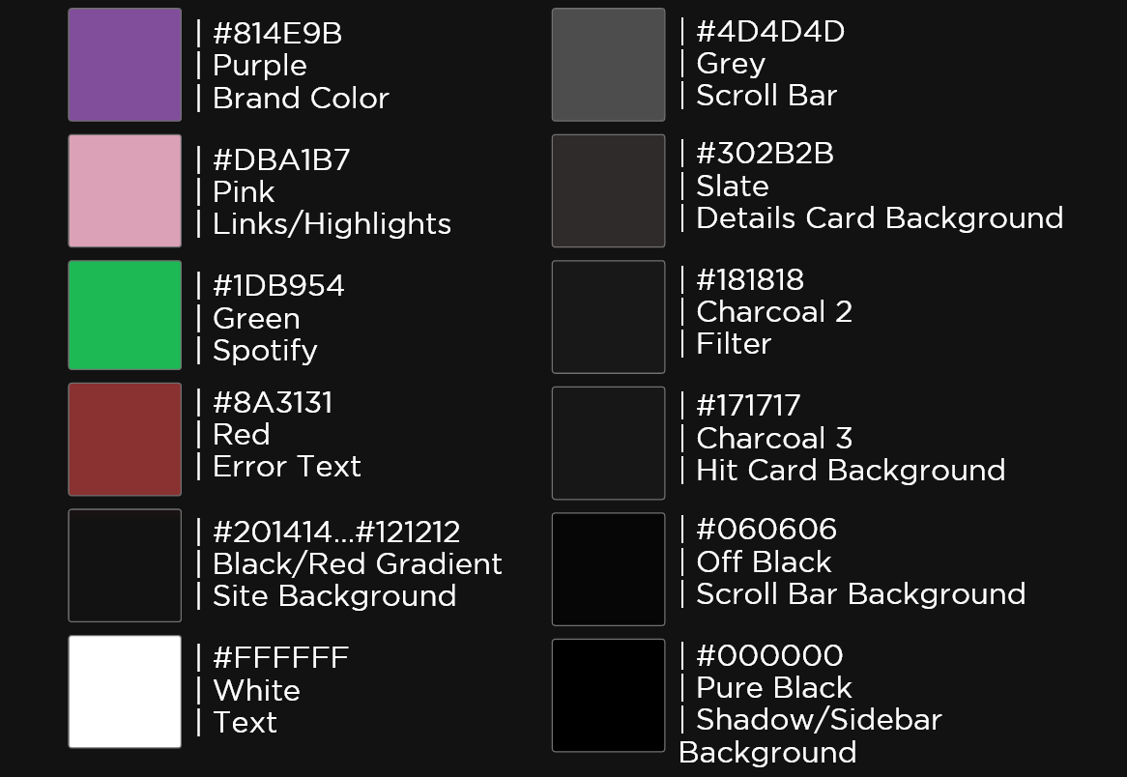

**Icons**

**Source –**

**Font Awesome v6.0.0 -** <https://fontawesome.com/>

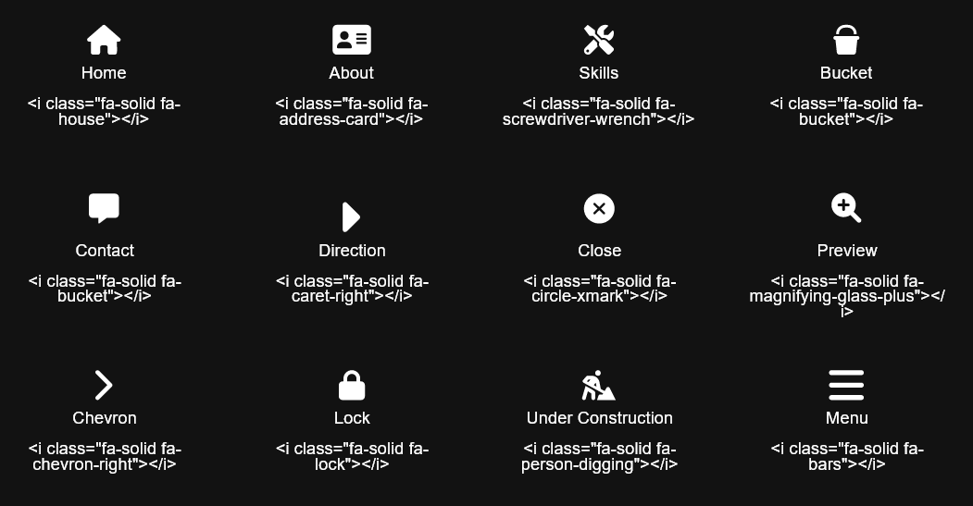

**Buttons**

**Primary Button –**

**Bootstrap 5 Buttons -** <https://getbootstrap.com/docs/5.0/components/buttons/>

**Default State -**

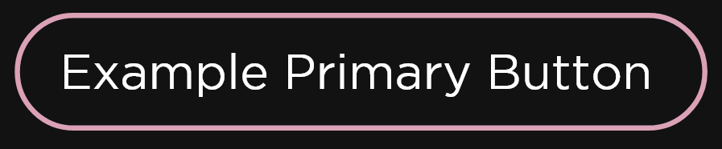

**Hover State –**

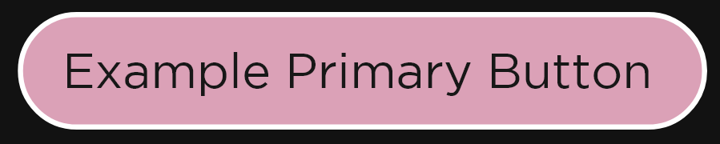

**Toggle State -**

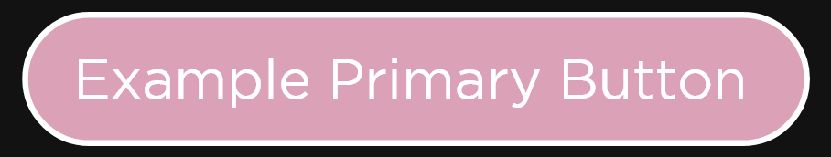

**Icon Button –**

**Default State -**



**Hover State –**



**Toggle State -**



**Checkboxes –**

**Bootstrap 5 Checkboxes -** <https://getbootstrap.com/docs/5.0/forms/checks-radios/>

**Default State -**

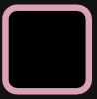

**Hover State –**

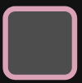

**Toggle State -**

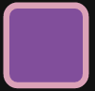

**Alerts**

**Bootstrap Element –**

**Bootstrap 5 Alerts -** <https://getbootstrap.com/docs/5.0/components/alerts/>

**Alerts (Badge) –**

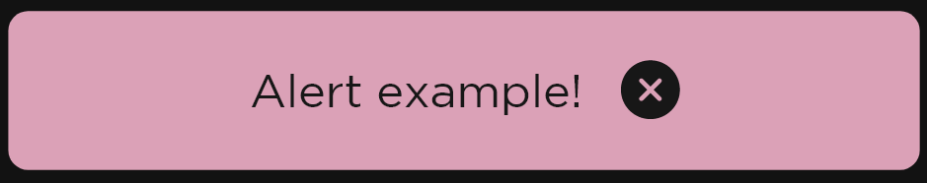

**Notes –**

* **When an alert is displayed, it is shown with an overlay filter, covering and darkening the rest of the site.**

**Form Fields**

**Bootstrap Element –**

**Bootstrap 5 Floating Label -** <https://getbootstrap.com/docs/5.0/forms/floating-labels/>

**Text Field (Standard w/Label) –**

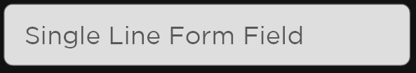

**Text Field (Multiline w/Label) –**

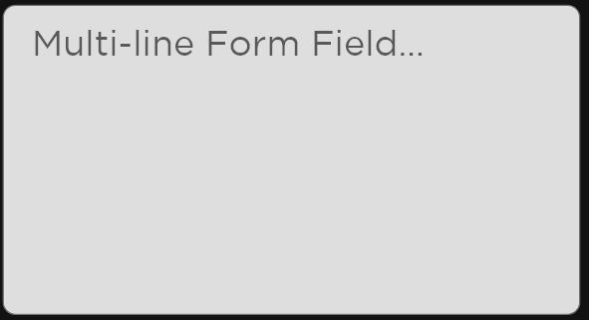

**Notes –**

* **When a single line form field with a label is typed in, the field label is minimized and “floated” to the top left of the field.**

**Dropdowns**

**Bootstrap Element –**

**Bootstrap 5 Dropdowns -** [**https://getbootstrap.com/docs/5.0/components/dropdowns/**](https://getbootstrap.com/docs/5.0/components/dropdowns/)

**Dropdown (Dropdown Button) –**

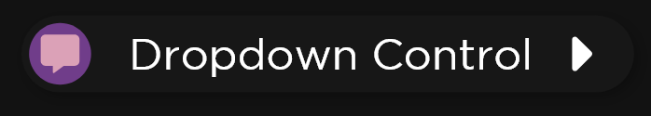

**Dropdown (Dropdown Button) –**

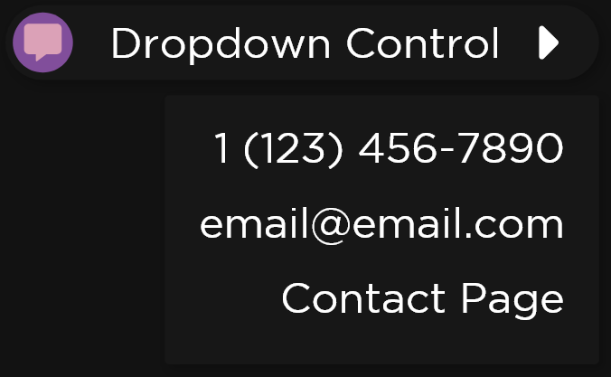

**Notes –**

* **Contact Page Dropdown entry is a link to the contact page**
* **Phone Number and Email are loaded from the Django Admin Screen.**

**Navigation Link Cards**

**Bootstrap Element –**

**Bootstrap 5 Cards -** <https://getbootstrap.com/docs/5.0/components/card/>

**Card –**

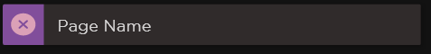

**Notes –**

* **Clicking on the card directs the user to the associated page.**

**Hit Cards**

**Bootstrap Element –**

**Bootstrap 5 Cards -** <https://getbootstrap.com/docs/5.0/components/card/>

**Card –**

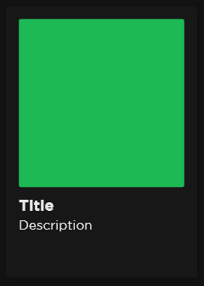

**Notes –**

* **Clicking on the card directs the user to the associated hit.**

**Embedded Playlists**

**Source –**

**Spotify Playlist Embedding –**

**<iframe style="border-radius:12px" src="https://open.spotify.com/embed/playlist/6bS3bTeu26LOlahLEWvtcT?utm_source=generator" width="100%" height="380" frameBorder="0" allowfullscreen="" allow="autoplay; clipboard-write; encrypted-media; fullscreen; picture-in-picture"></iframe>**

**Mockup –**



**Notes –**

* **The playlist does NOT start playing by default.**
* **The playlist is always at the positioned at the bottom of the screen, no matter where the user has scrolled to.**
* **The Playlist is not displayed while the site is in the mobile version.**

**Image Preview**

**Example –**

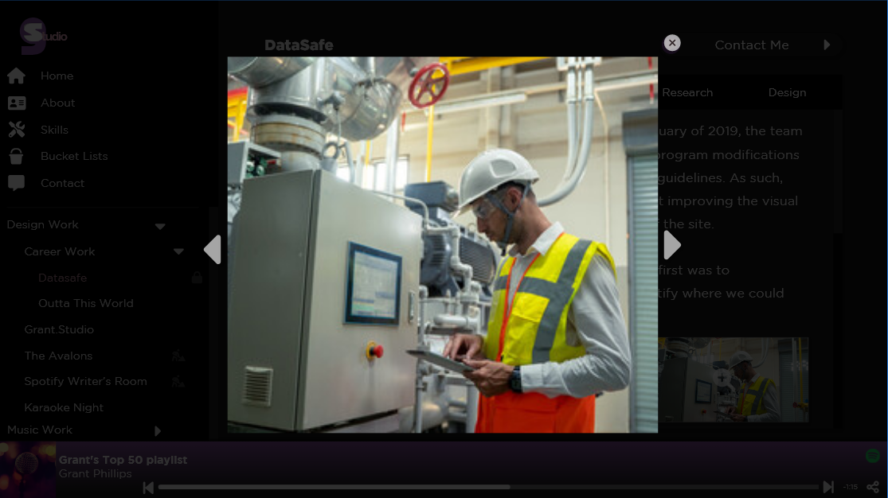

**Notes –**

* **When an Image Preview is displayed, it is shown over a dark overlay that covers the rest of page.**
* **There are “Previous” and “Next” arrows that cycle through the images in set in that preview cycle.**
* **Clicking on either the dark overlay or the close button closes the preview.**

**Carousel**

**Bootstrap Element –**

**Bootstrap 5 Carousel -** <https://getbootstrap.com/docs/5.0/components/carousel/>

**Example –**

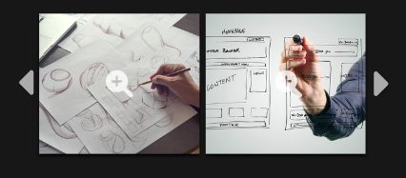

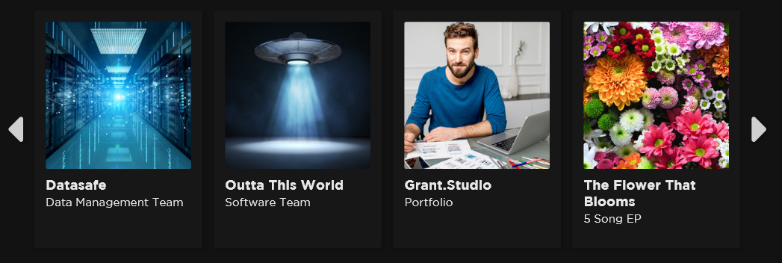

**Notes –**

* **Clicking the “Previous” or “Next” buttons in the carousel cycle through the items in the carousel.**

**Sidebar Menu**

**Desktop –**

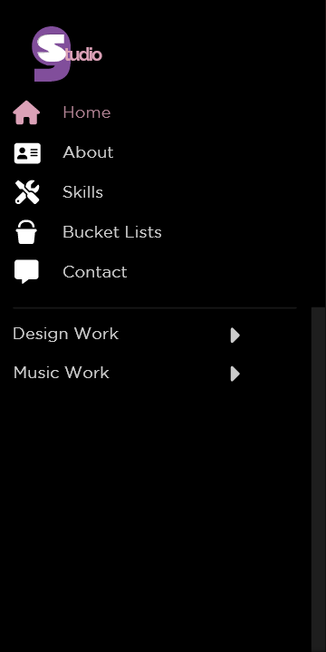

**Mobile –**



**Notes –**

* **When a page is clicked on, that page’s link and associated icon become highlighted in the sidebar.**
* **The bottom portion of the sidebar that displays the folders and the hits is scrollable.**
* **When an arrow is clicked on in the folder navigation portion is clicked, the folder either expands or collapses**
  + **When the arrow is facing the right, that means the folder is collapsed.**
  + **When the arrow is facing down, that means the folder is expanded.**
* **The banner at the top of the mobile site is displayed at the top at all times.**
* **The Logo in the banner acts as a “Home” button.**
* **When in the mobile version of the site, the sidebar is hidden until the “Menu” button at the top is clicked.**
* **If the menu button is clicked again, the sidebar is hidden.**
* **When the Mobile Sidebar is unhidden, it behaves similarly to the desktop version.**
  + **The mobile sidebar does not show the logo, as it is in the banner.**
* **When a page is clicked on from the sidebar, the sidebar is then hidden.**
* **If a hit has the “isHidden” flag turned on, then that item will not display in the sidebar.**

**Home**

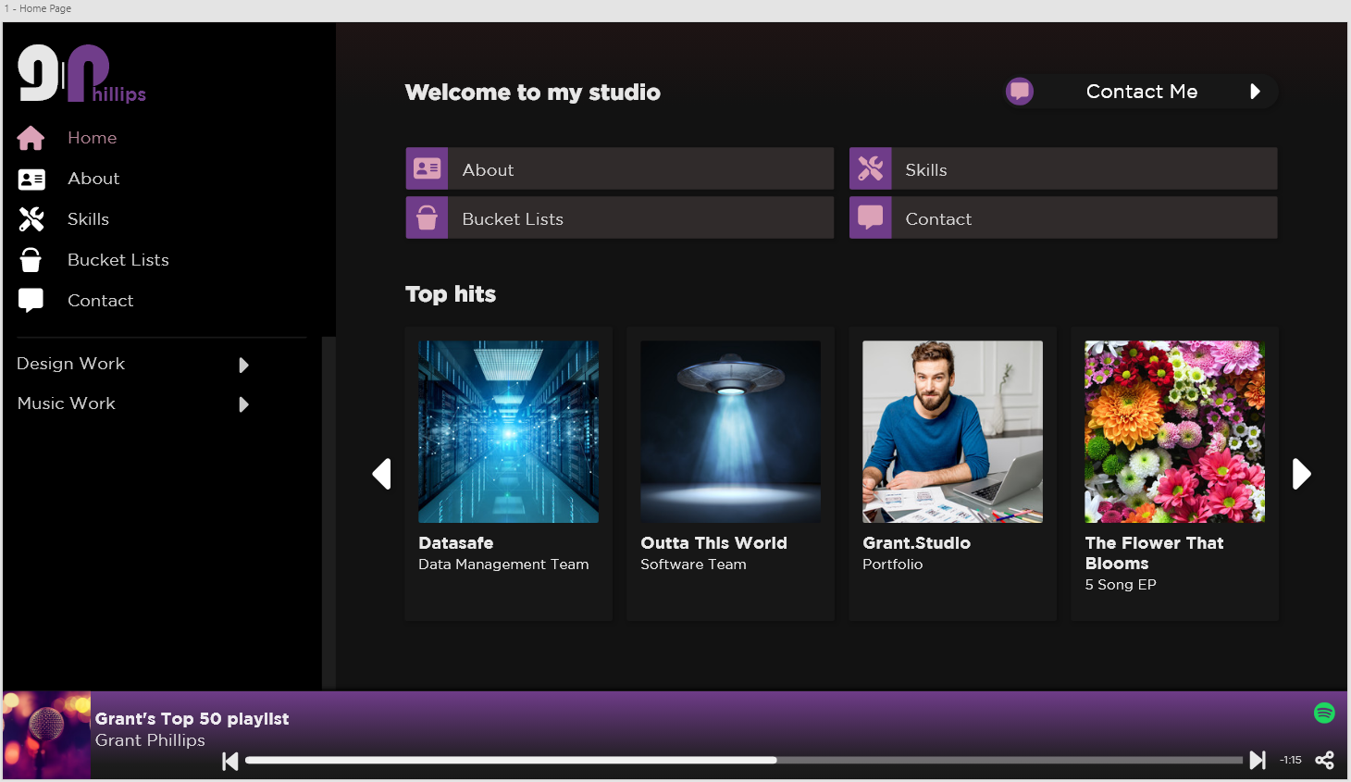

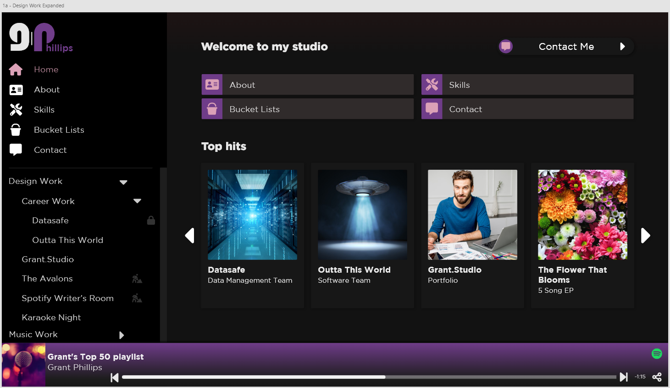

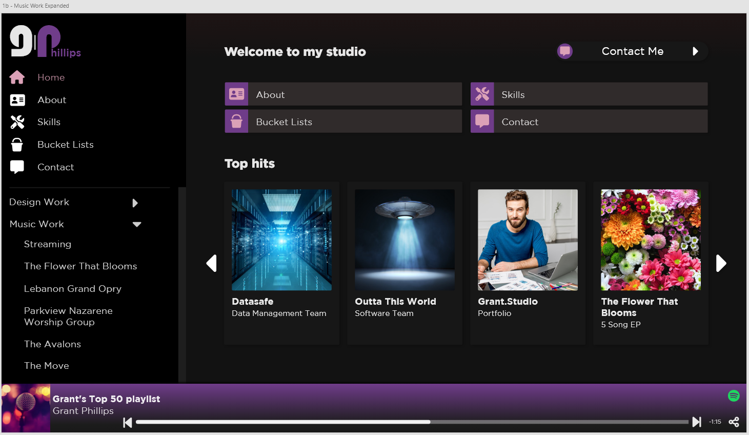

**Notes –**

* **The Top hits are gathered from hits that have the “Top Hit” flag selected on the Django Admin Screen.**
* **If a Top Hit has its “isHidden” flag selected, it is hidden from the carousel.**
* **The Home screen is the default screen shown when accessing the site.**

**About**

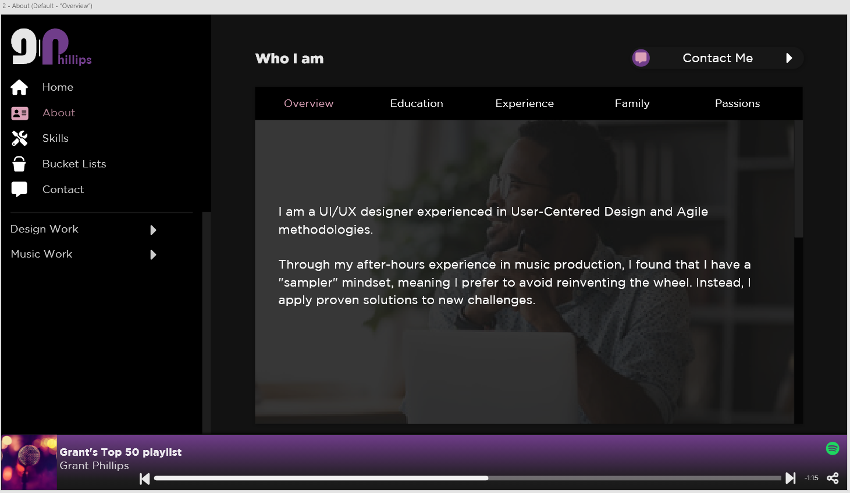

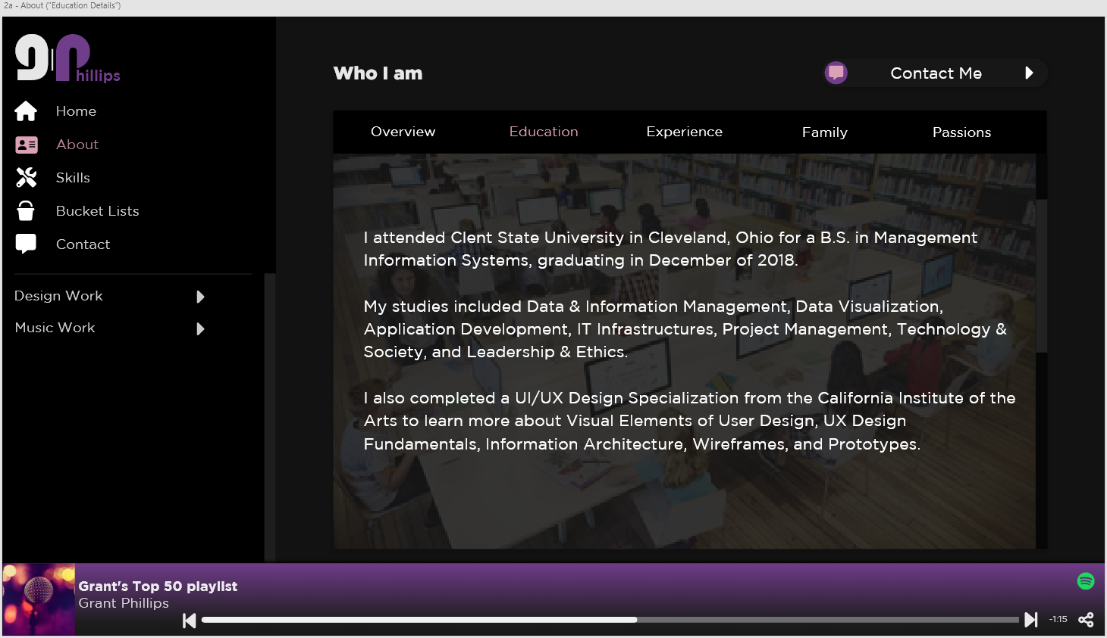

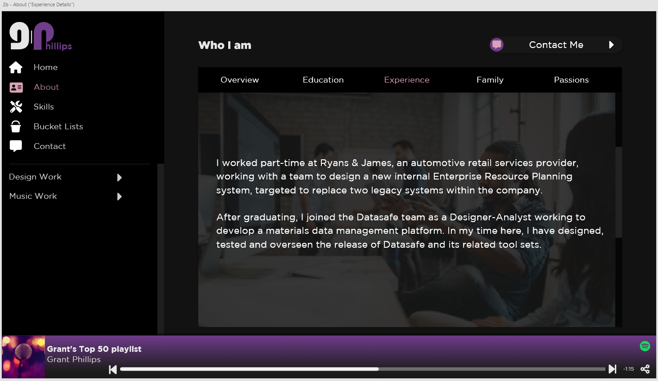

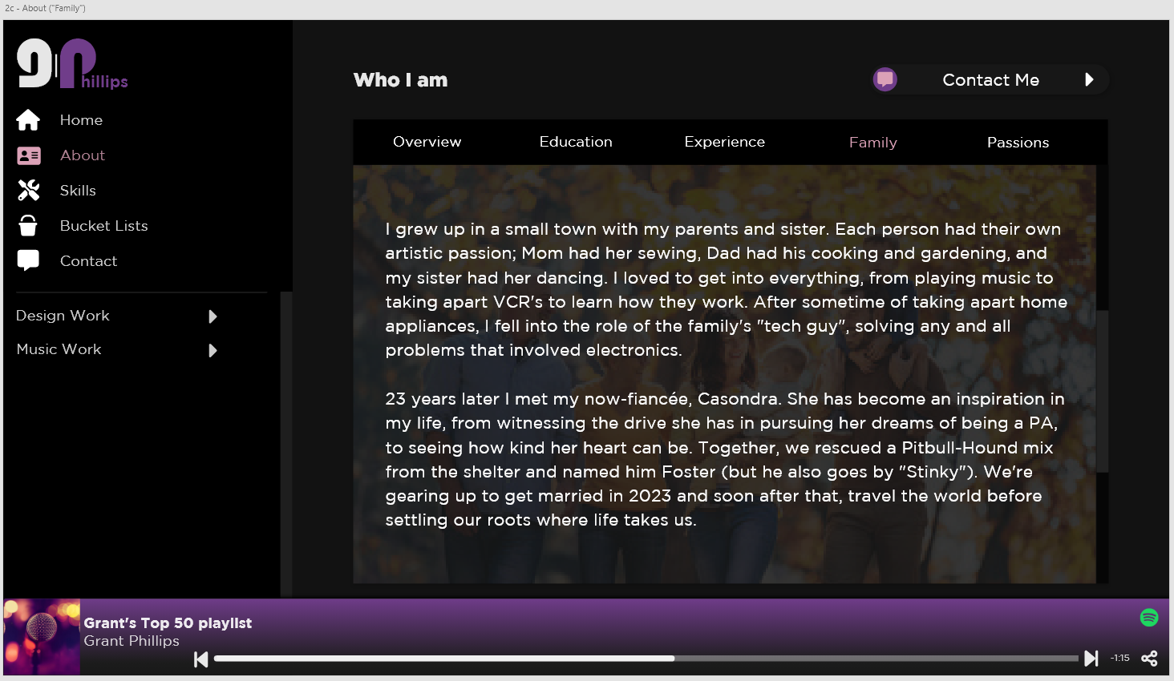

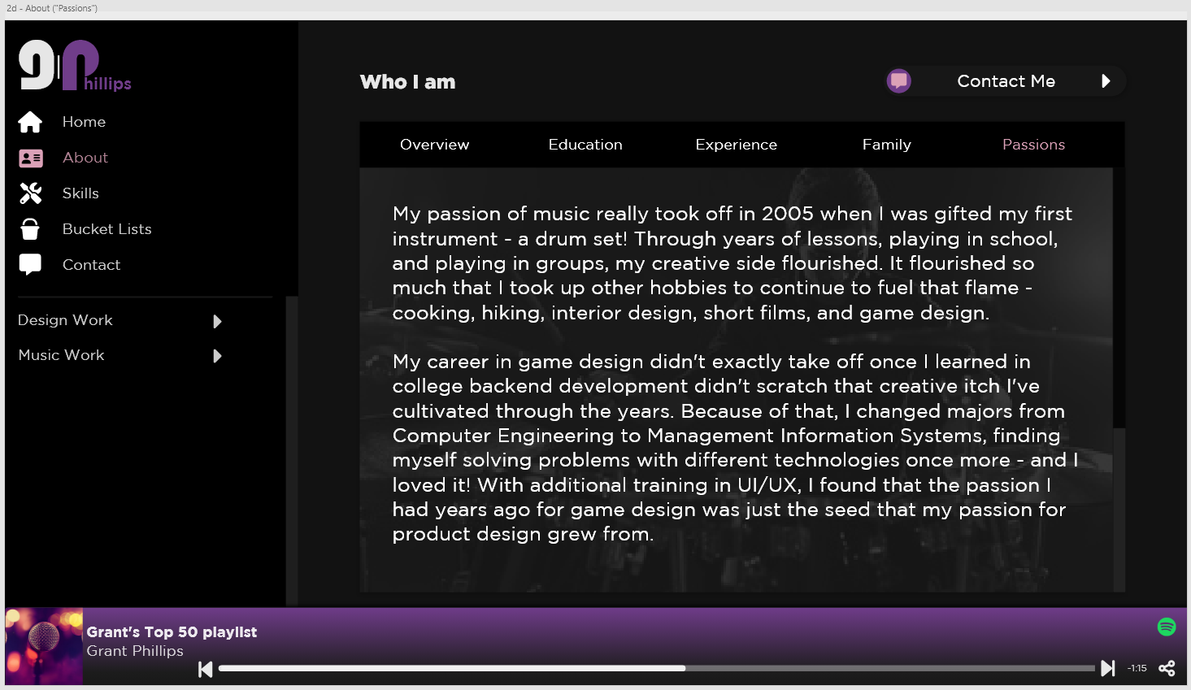

**Notes –**

* **The element used for the view table is the Bootstrap 5 Scroll Spy -** <https://getbootstrap.com/docs/5.0/components/scrollspy/>
* **The Scroll Spy can be navigated through the links at the top or the scroll bar.**
* **Above the background image in each section is a dark overlay to make the text stand out more.**
* **Titles, Content, and background images on this page are loaded through the Django Admin Screen.**
* **Content on this screen is presented in block text format.**

**Skills**

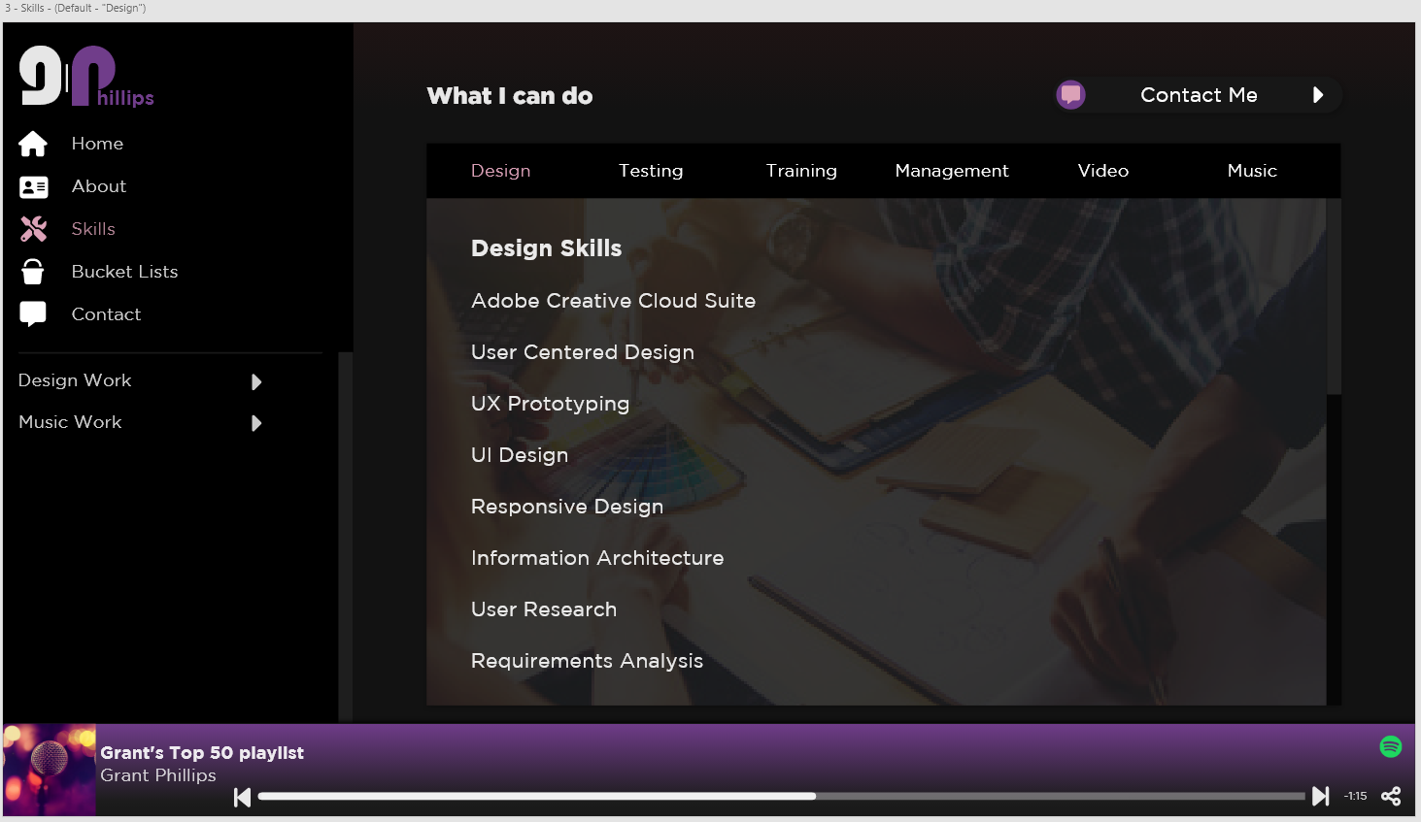

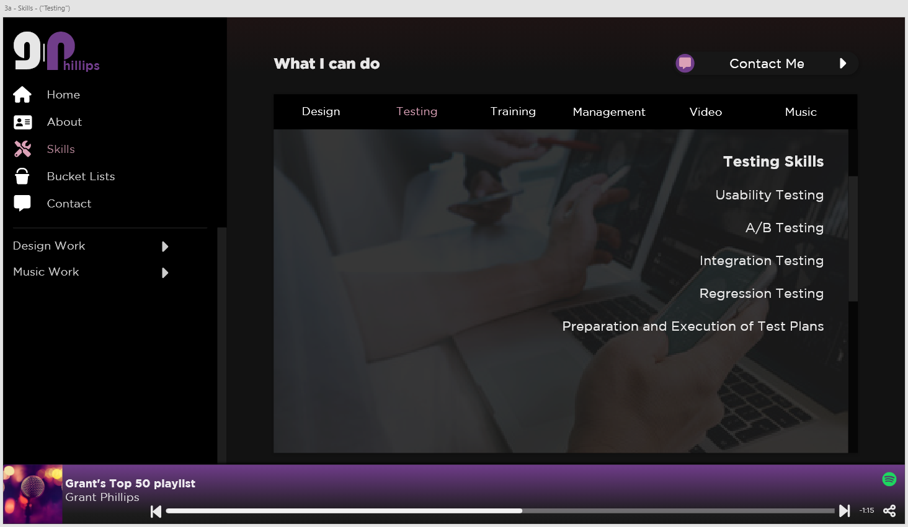

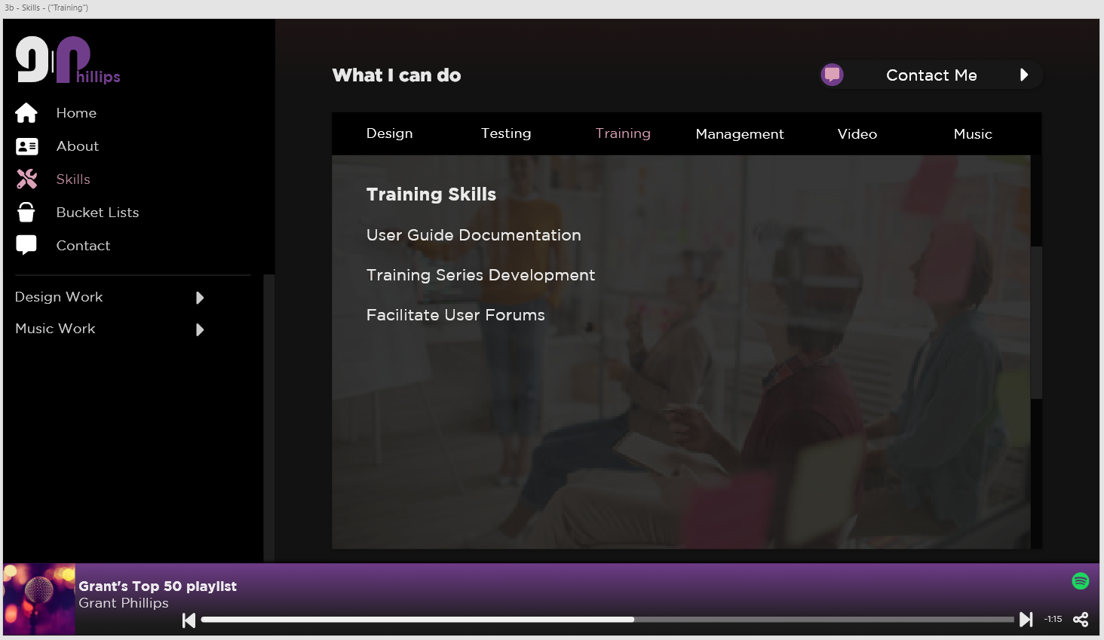

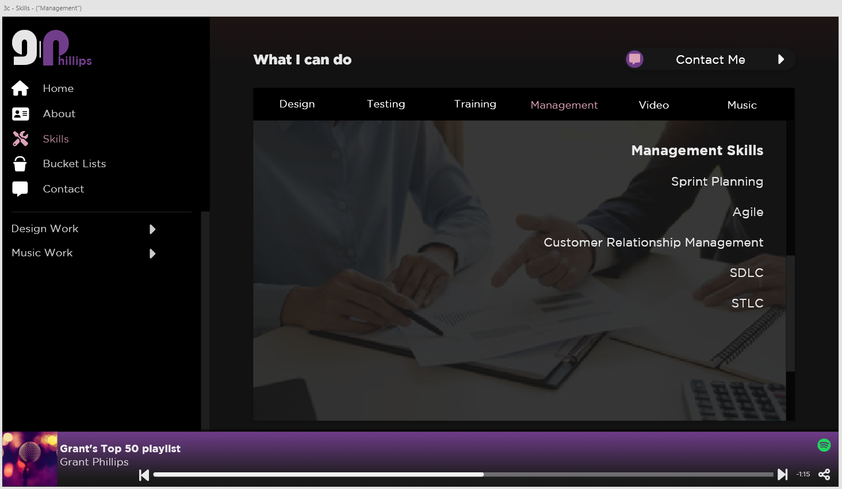

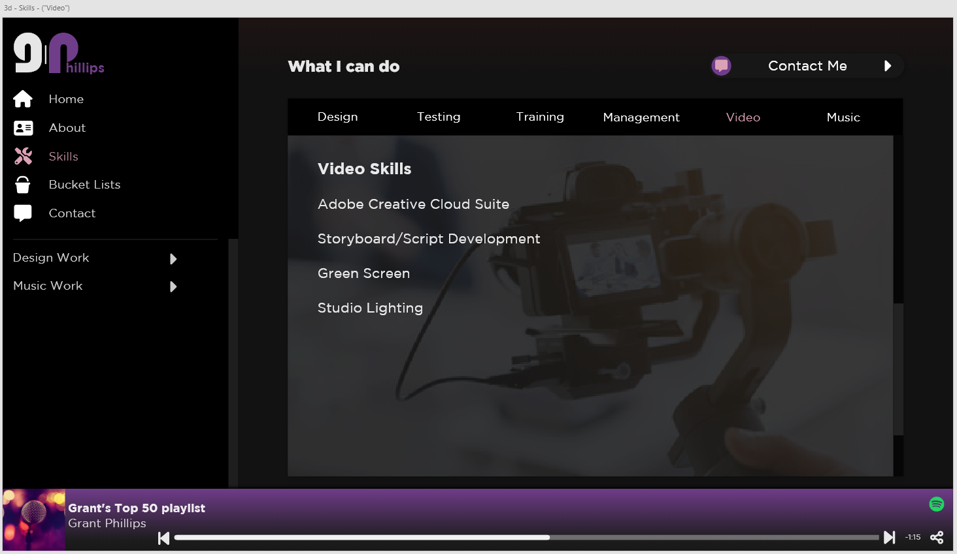

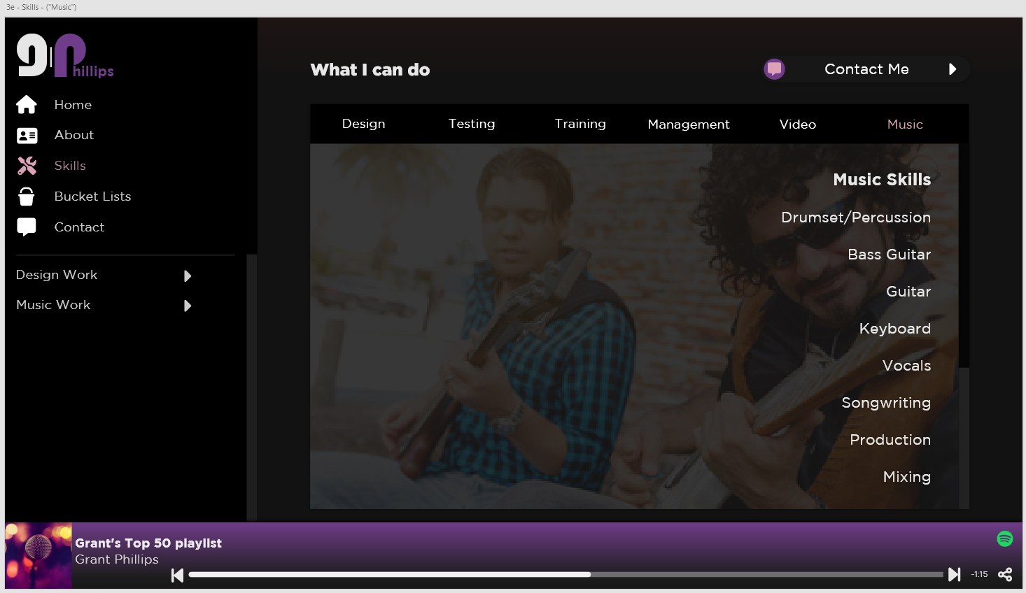

**Notes –**

* **The element used for the view table is the Bootstrap 5 Scroll Spy -** <https://getbootstrap.com/docs/5.0/components/scrollspy/>
* **The Scroll Spy can be navigated through the links at the top or the scroll bar.**
* **Above the background image in each section is a dark overlay to make the text stand out more.**
* **Titles, Content, and background images on this page are loaded through the Django Admin Screen.**
* **Content on this screen is presented in list text format.**

**Goals**

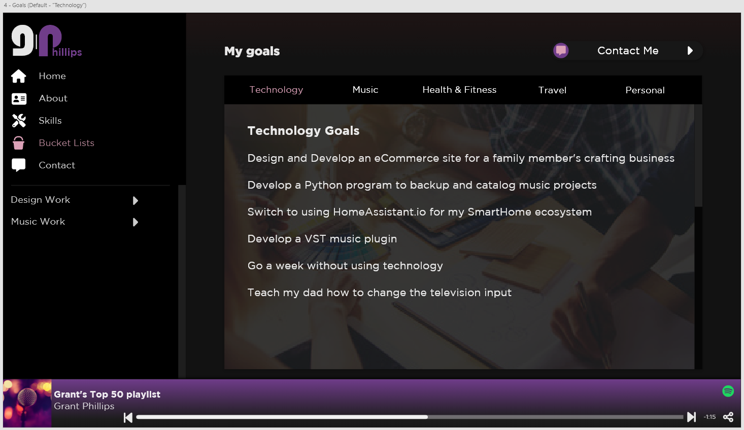

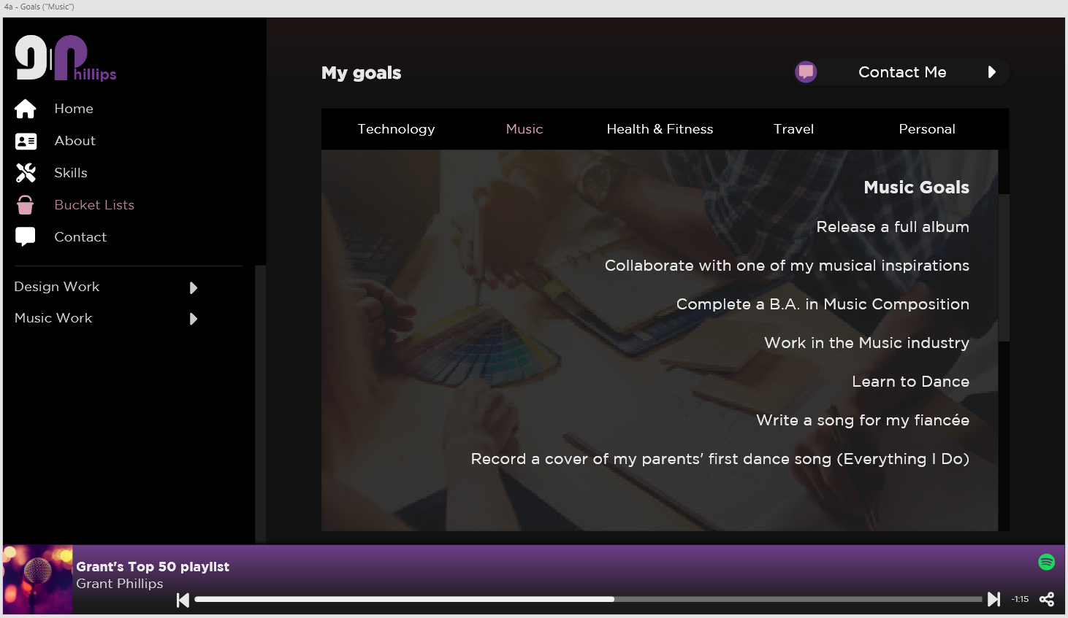

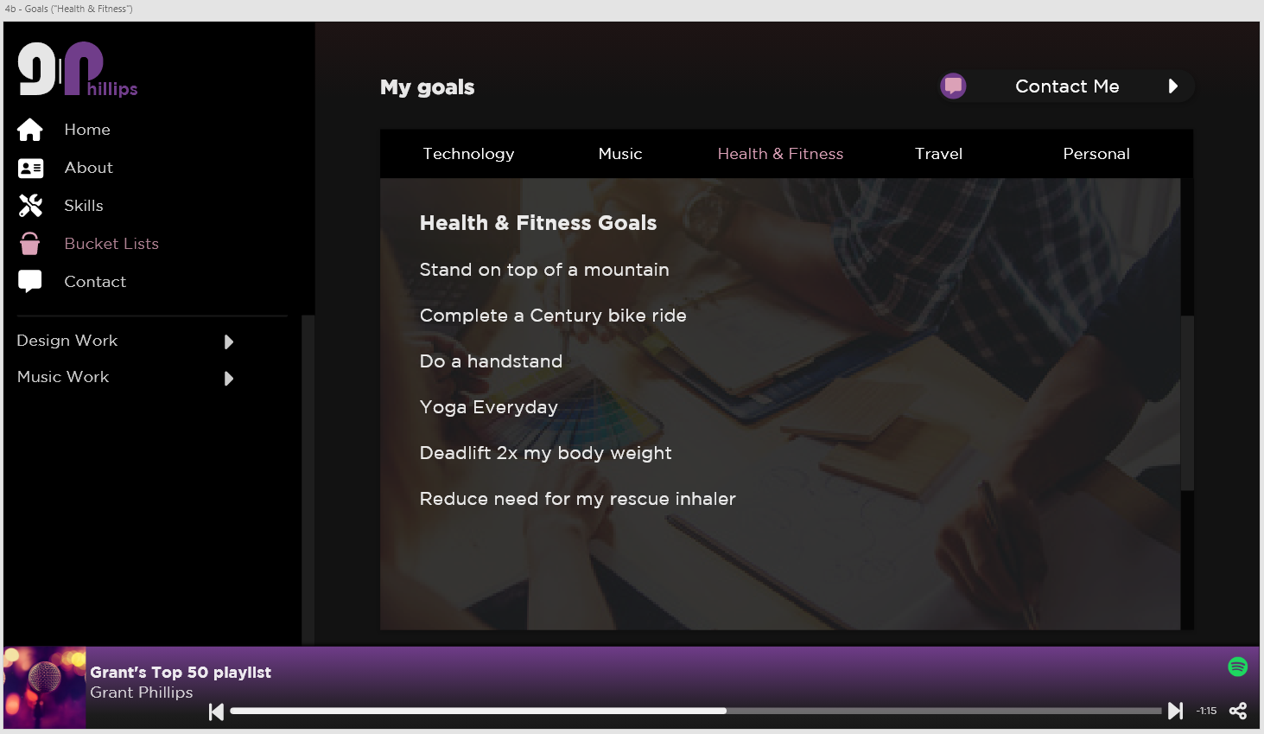

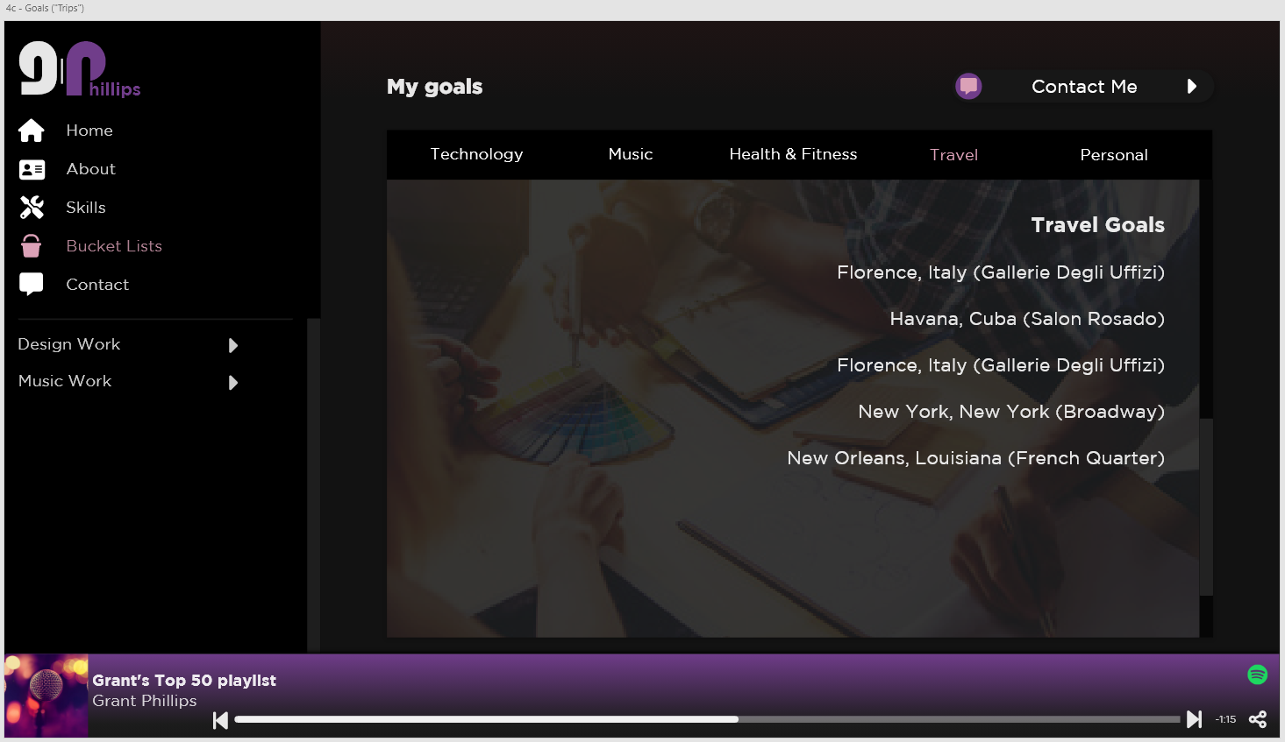

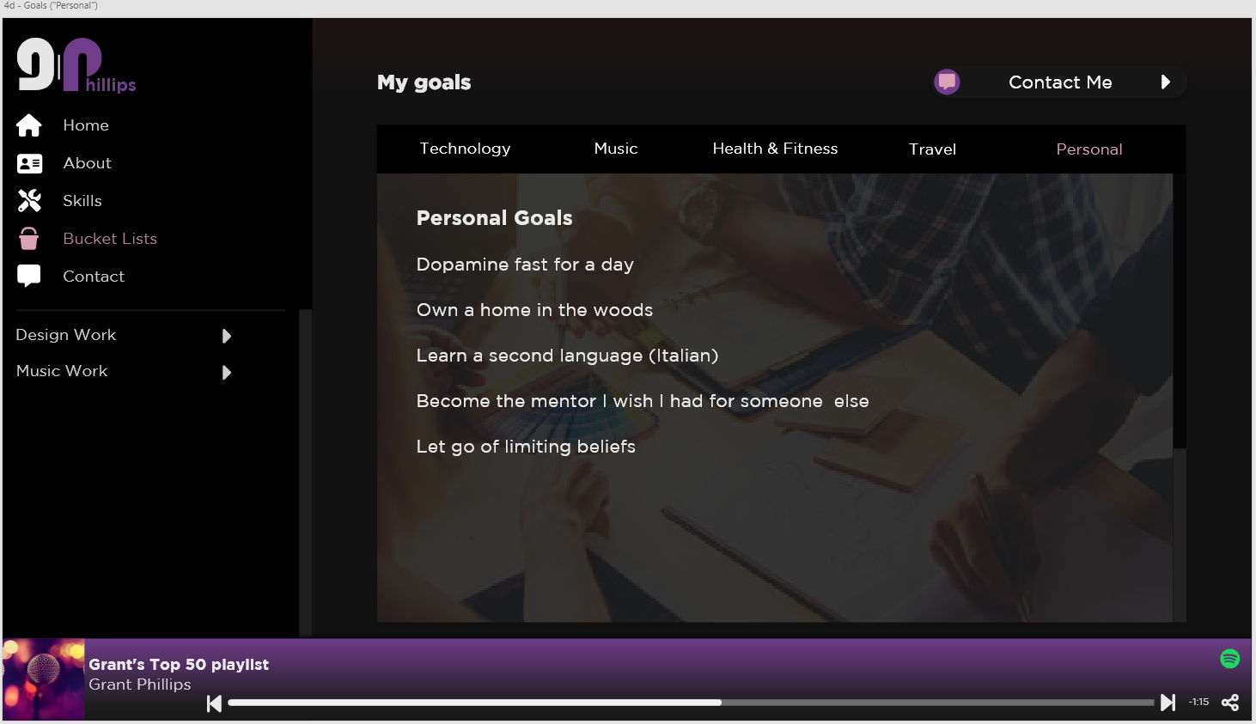

**Notes –**

* **The element used for the view table is the Bootstrap 5 Scroll Spy -** <https://getbootstrap.com/docs/5.0/components/scrollspy/>
* **The Scroll Spy can be navigated through the links at the top or the scroll bar.**
* **Above the background image in each section is a dark overlay to make the text stand out more.**
* **Titles, Content, and background images on this page are loaded through the Django Admin Screen.**
* **Content on this screen is presented in list text format.**

**Contact**

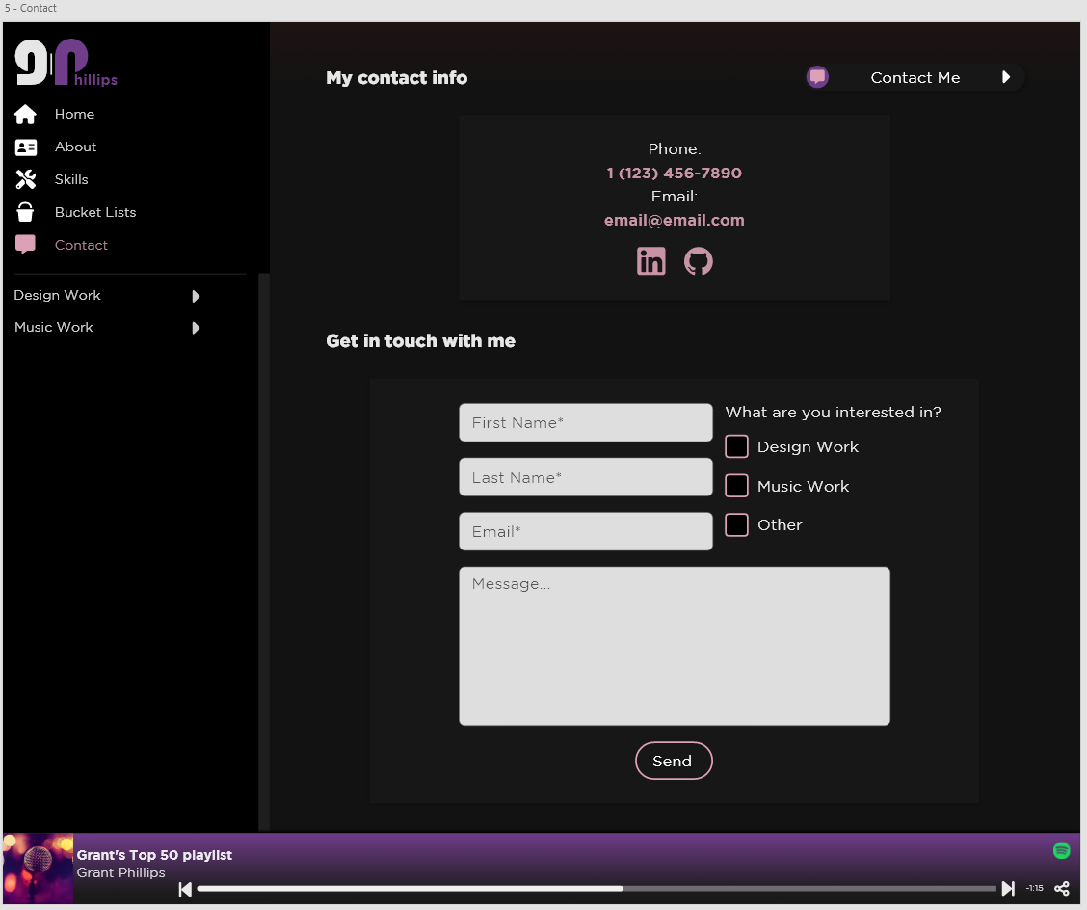

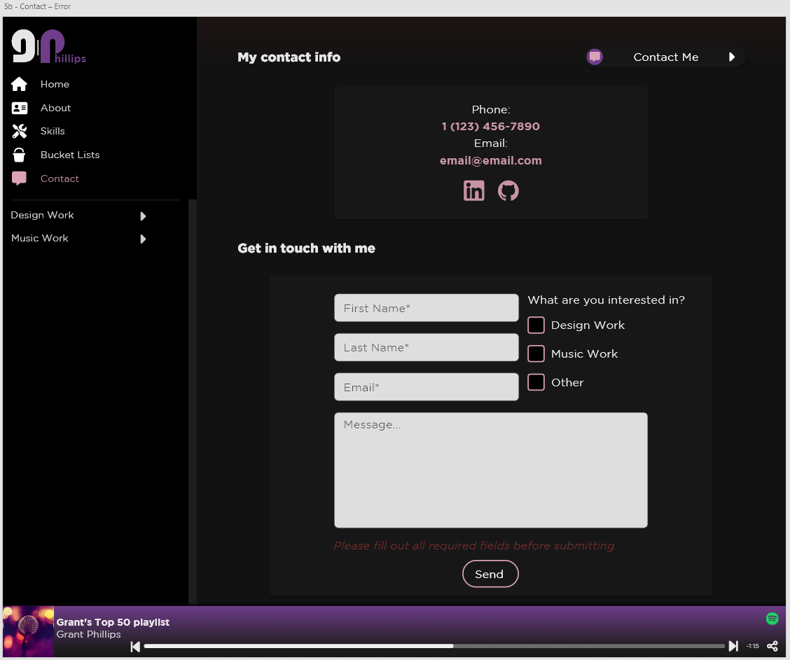

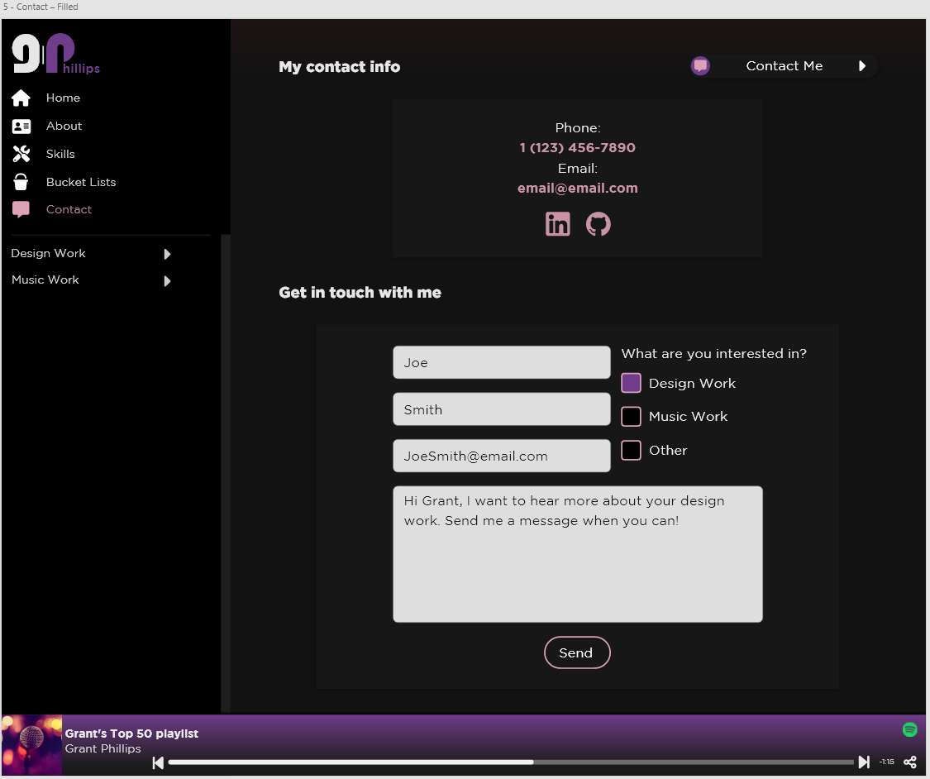

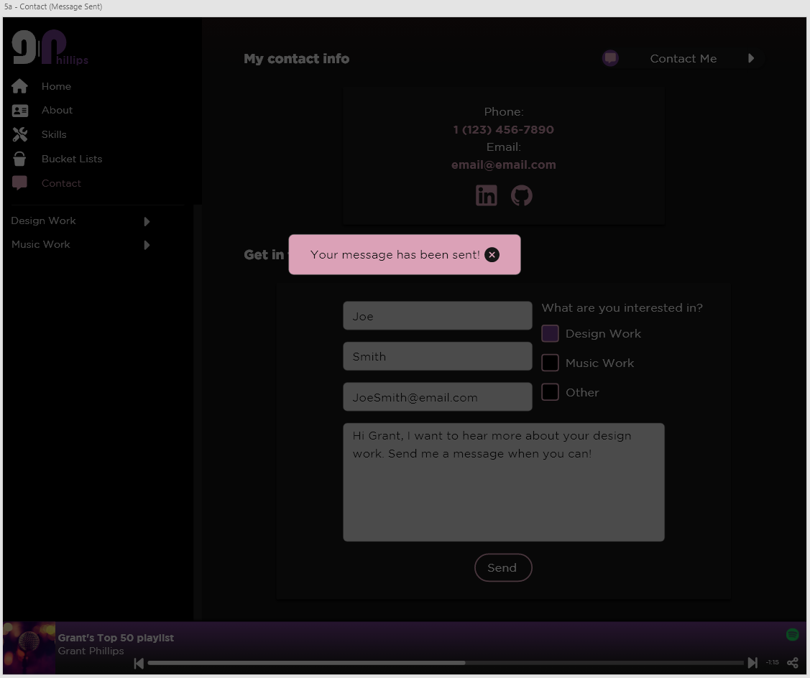

**Notes –**

* **Phone Number and Email are loaded from the Django Admin Screen**
* **Social Links (ex: LinkedIn, GitHub) are loaded in from Django admin screen.**
* **To submit a contact request, users must provide a first name, last name, and an email address.**
  + **If the above are not provided, then an error is displayed when the send button is clicked.**
* **When a successful message send happens, an alert is displayed.**
* **Upon closing the alert (by clicking the Close button or on the dark overlay, the page is refreshed to an empty contact form.**
* **Successful messages are logged in the Django Admin interface and forwarded to an email (the Admin User’s email).**

**Folder View**

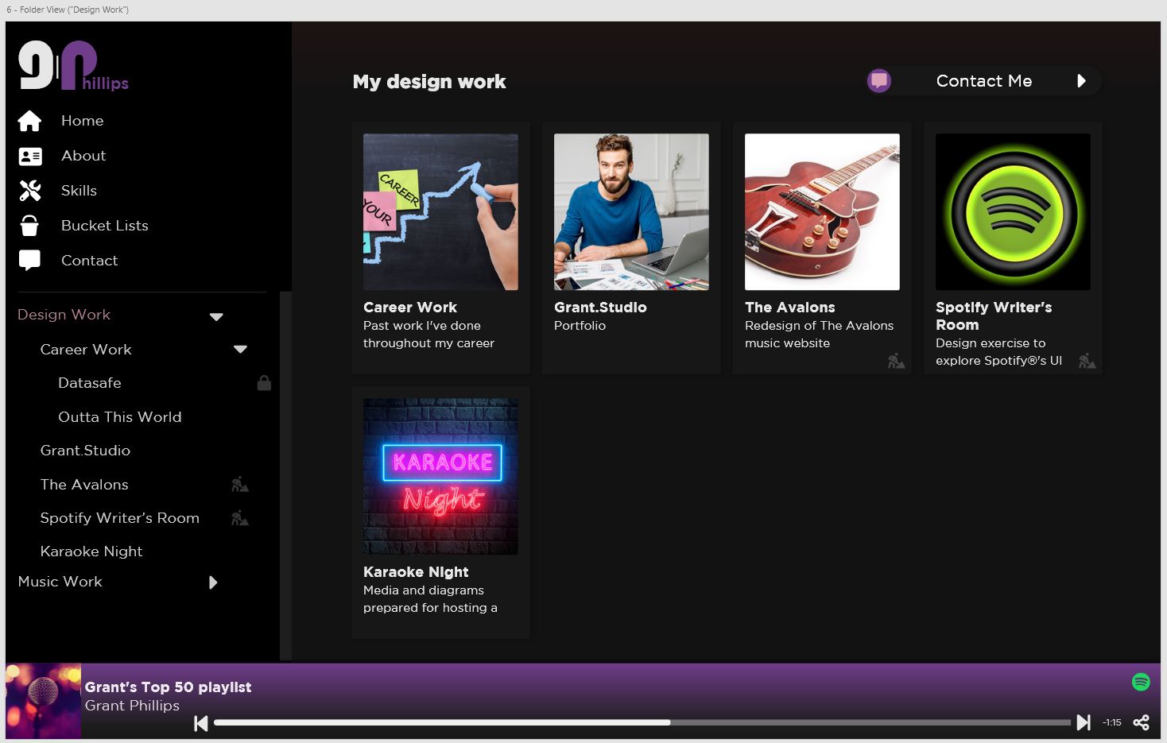

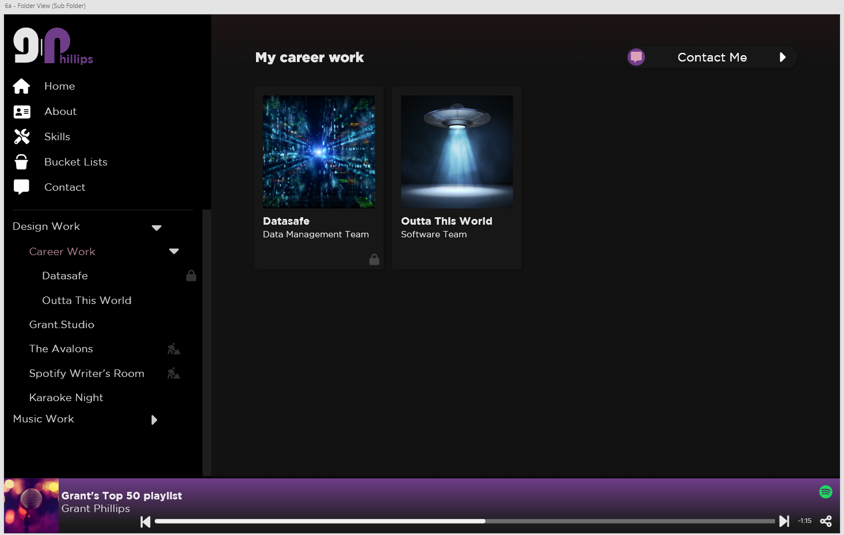

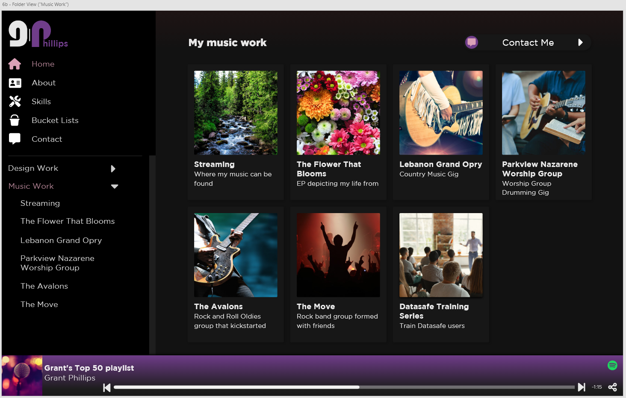

**Notes –**

* **Inside a folder can be other folders or hits in the form of Hit cards**
* **Navigating through the folder structure changes what is highlighted in the sidebar.**
* **If the user attempts to access a locked folder/hit, they are navigated to the Locked screen**
* **If a hit has the “isHidden” flag turned on, then that item will not display in any folder.**

**Design Hit**

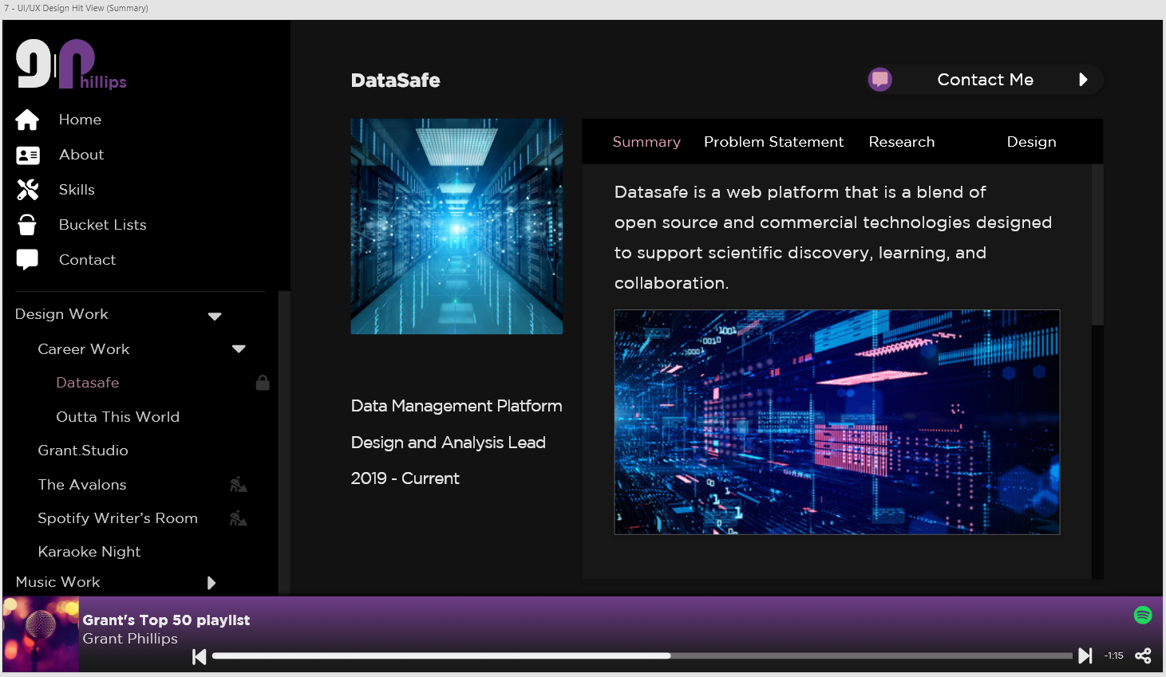

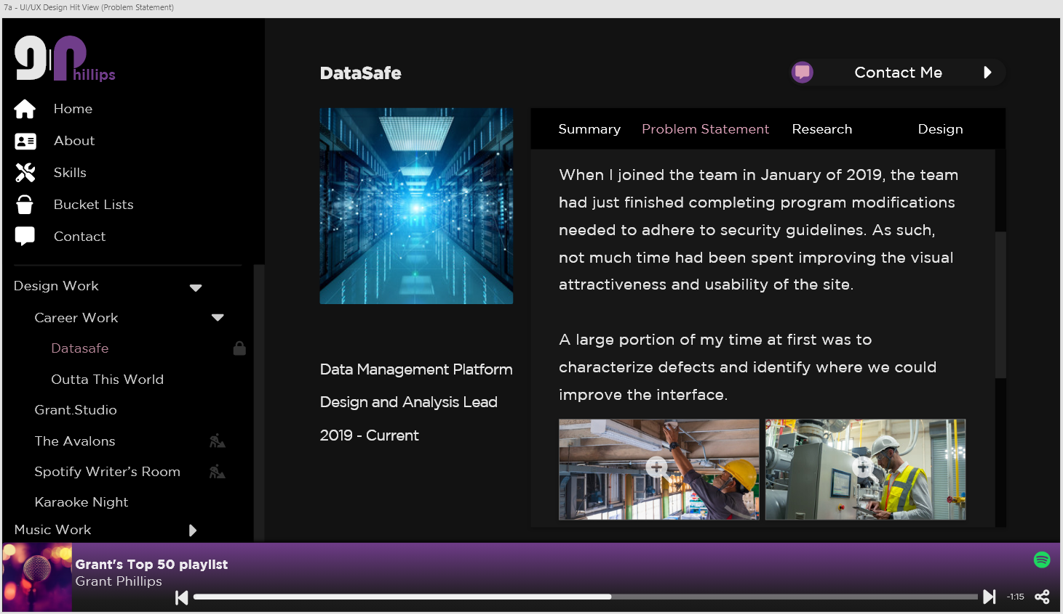

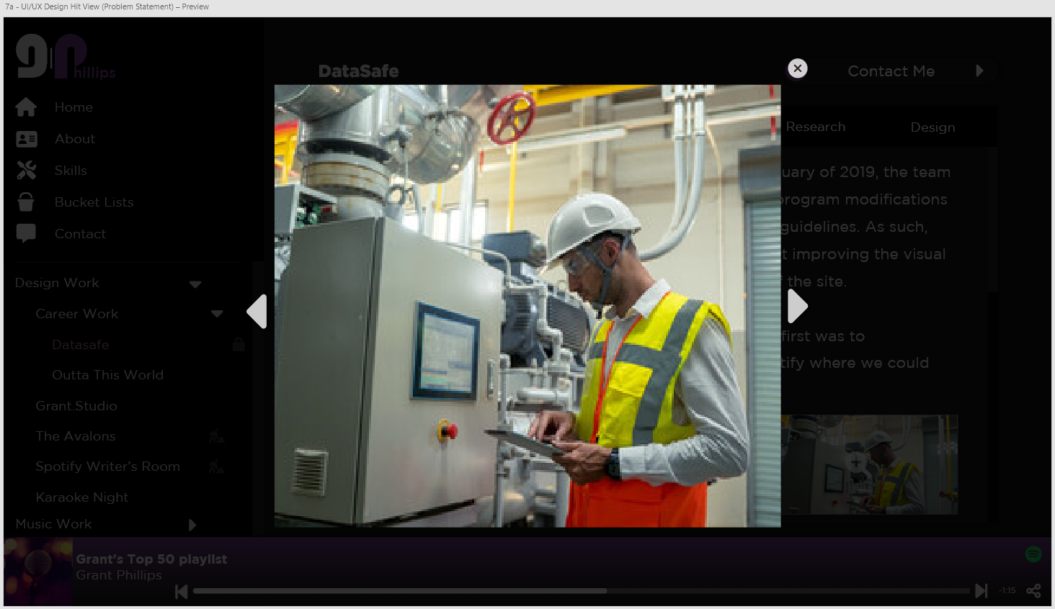

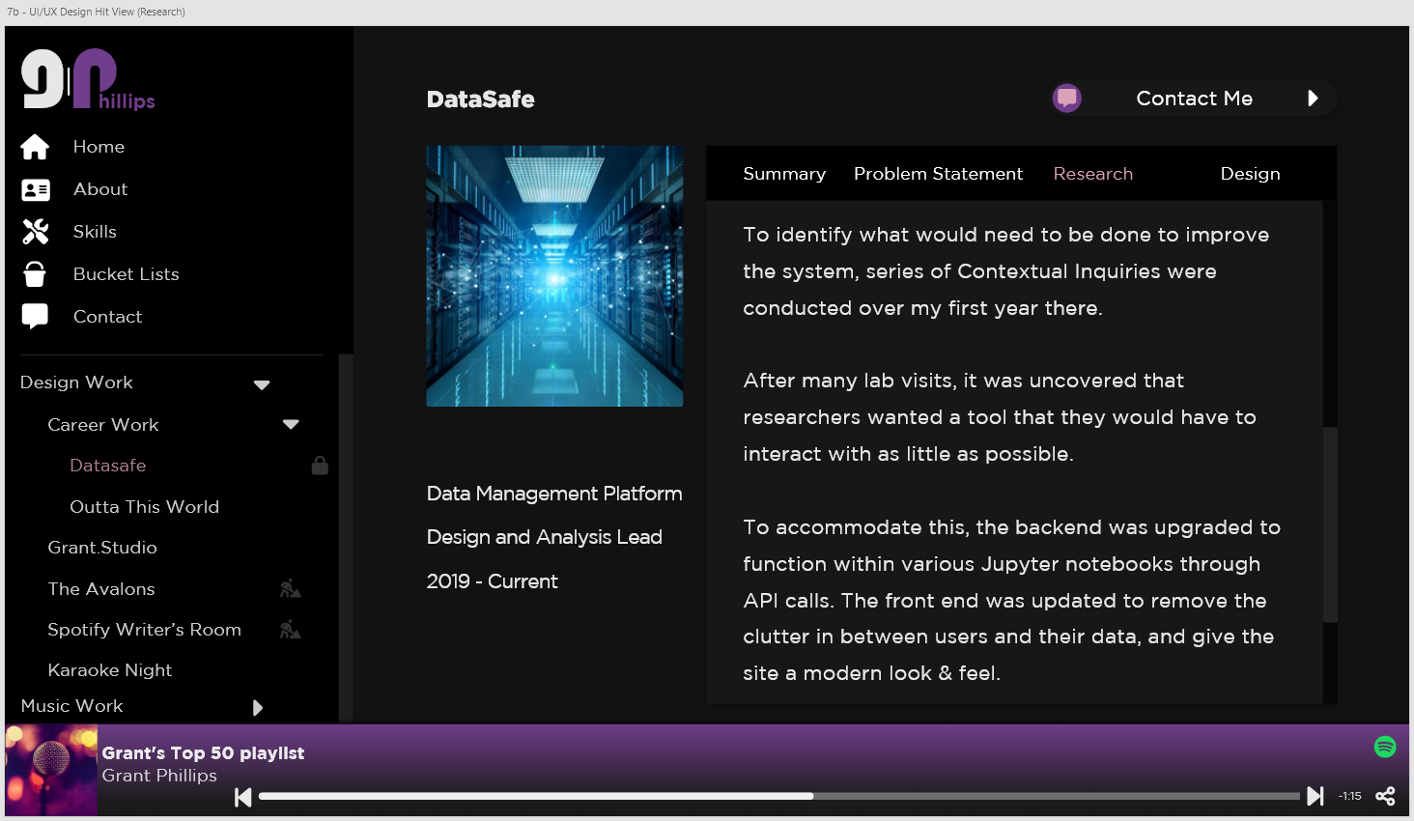

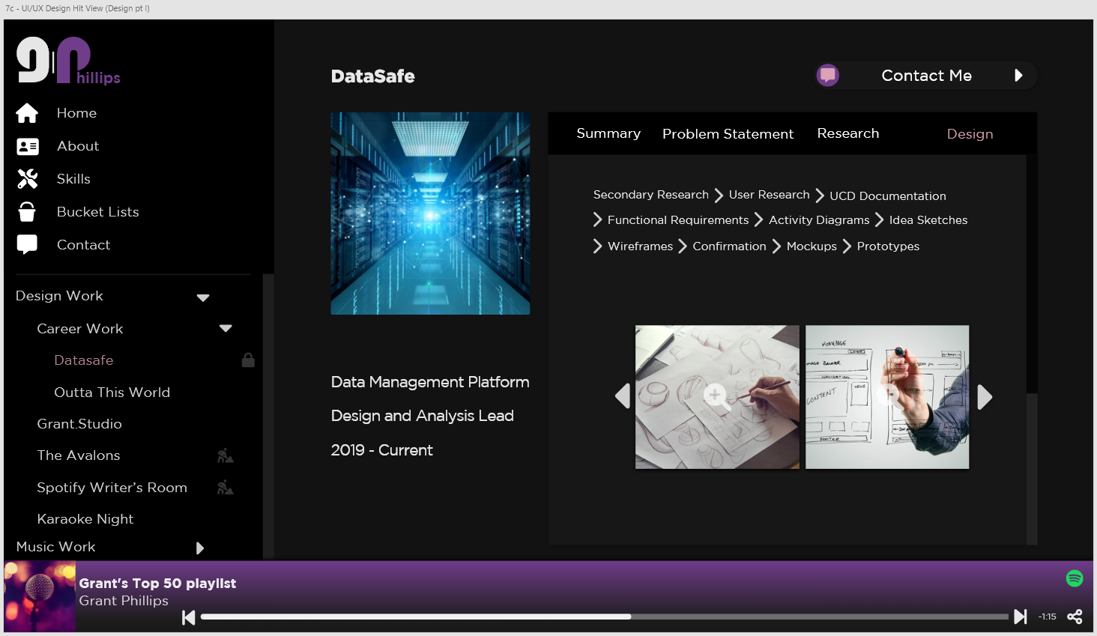

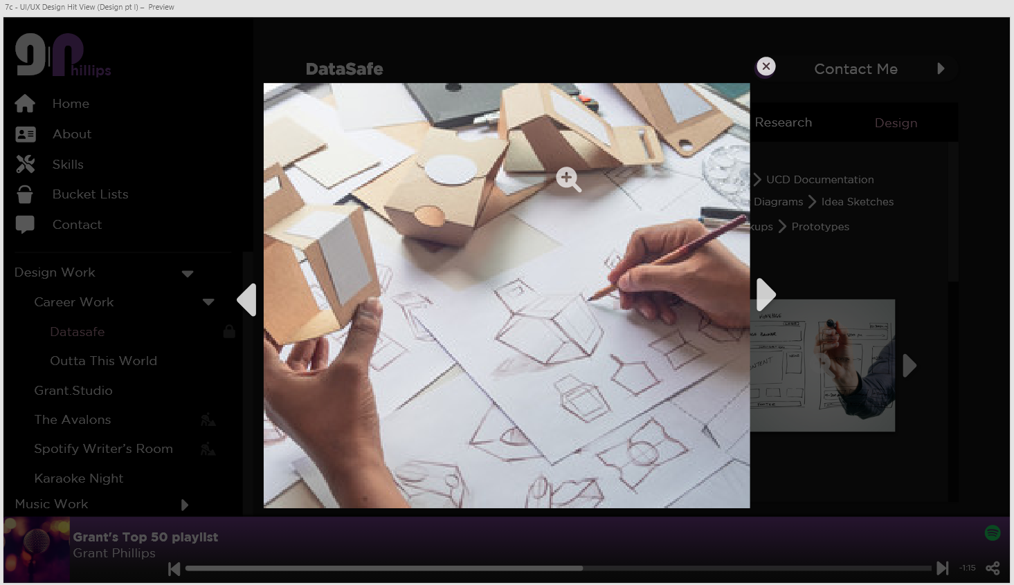

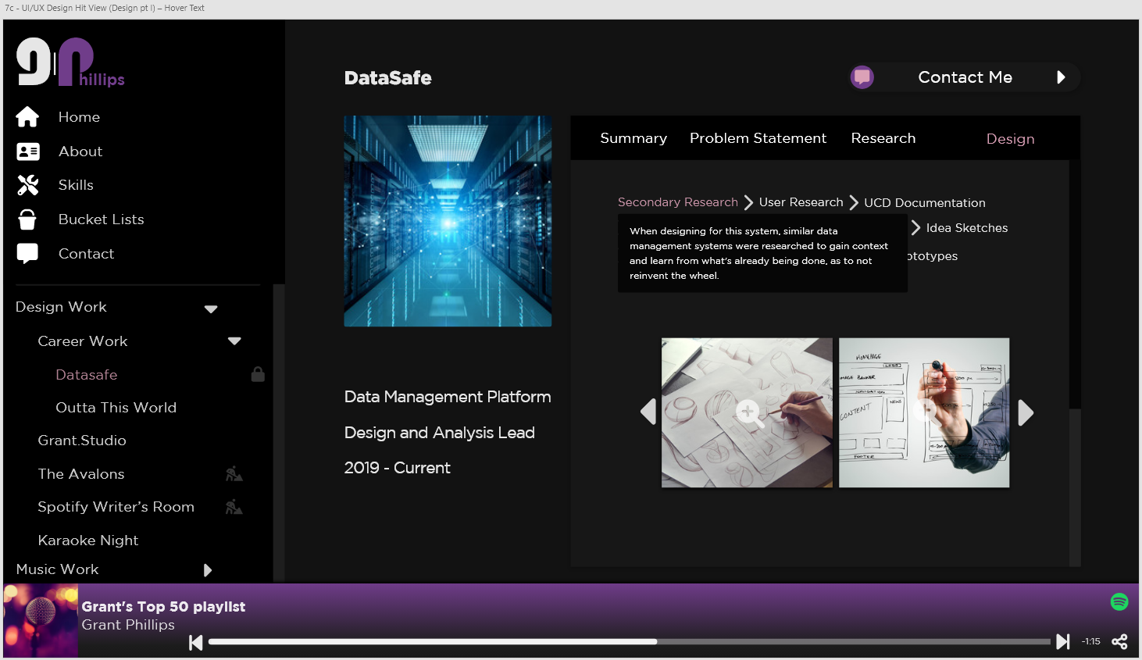

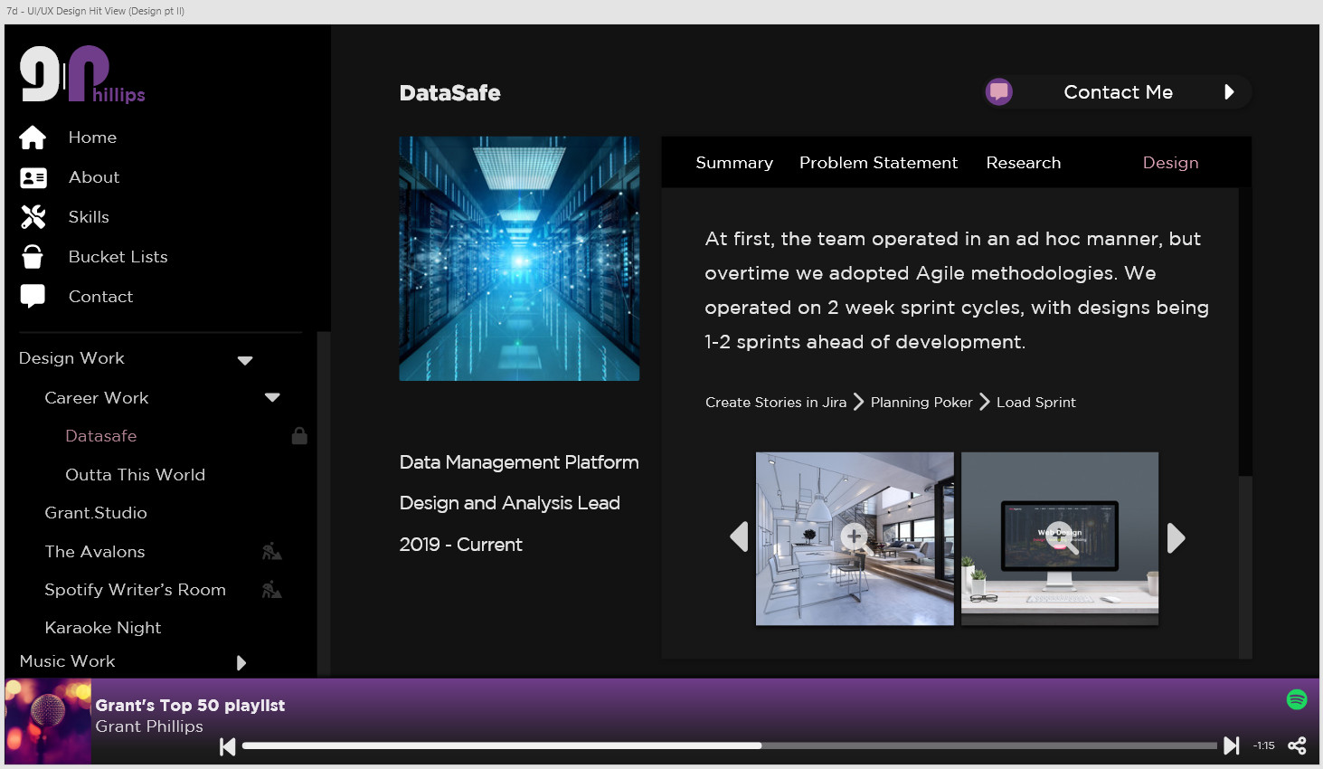

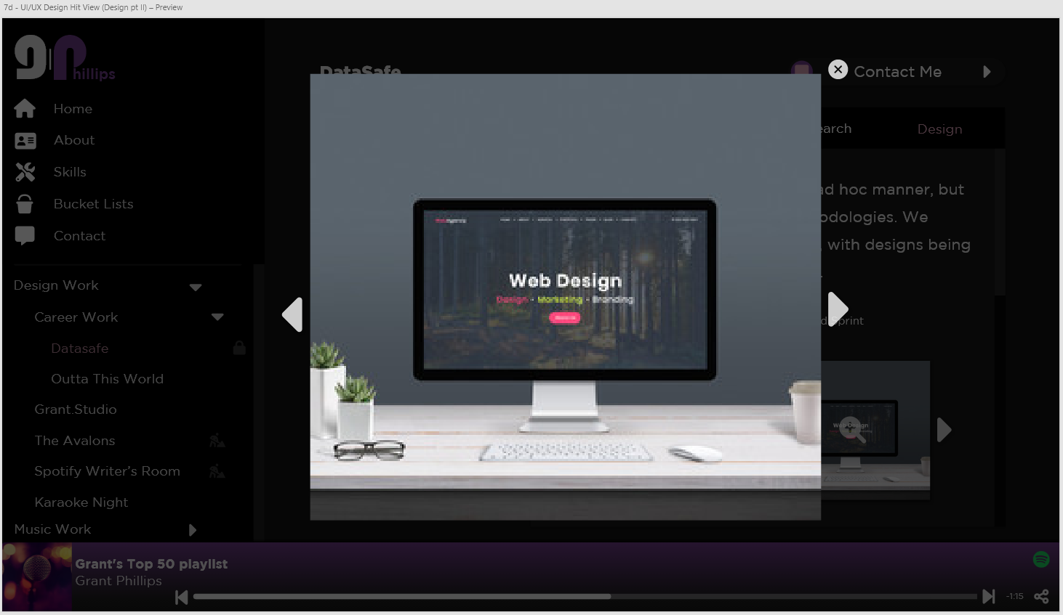

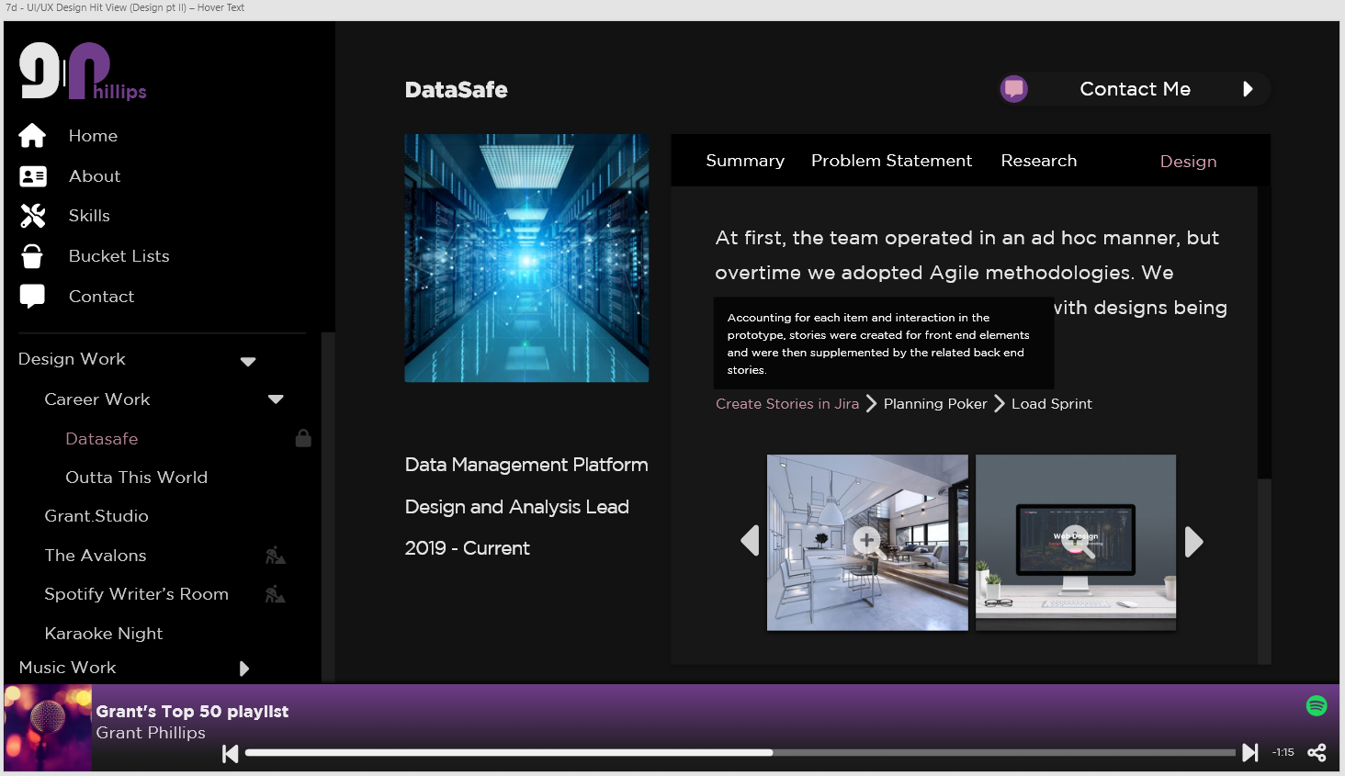

**Notes –**

* **The image on the Summary section is not previewable.**
* **The images on the Problem Statement section are previewable.**
* **There can only be two images on the Problem Statement section**
* **The Individual text items (separated by a chevron) in the Design section have tool tips that are displayed when clicked on.**
  + **When these items are hovered over, they change color to pink**
  + **The tool tip disappears if the user clicks on the site again.**
* **The user can cycle through/preview images in the design section.**

**Diagram Hit**

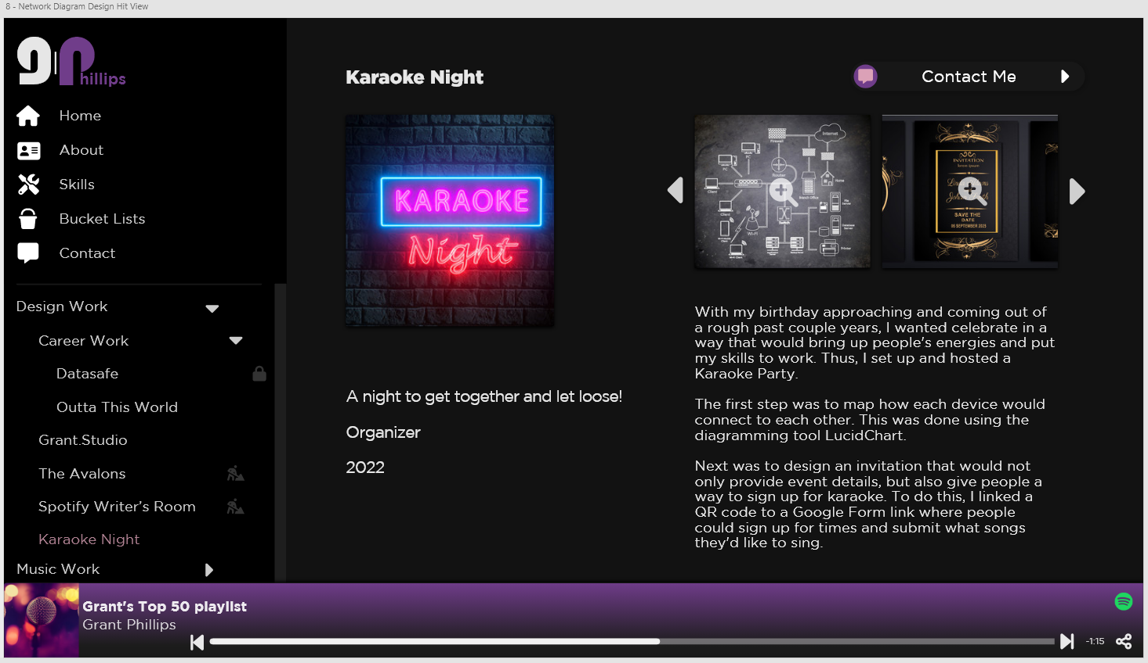

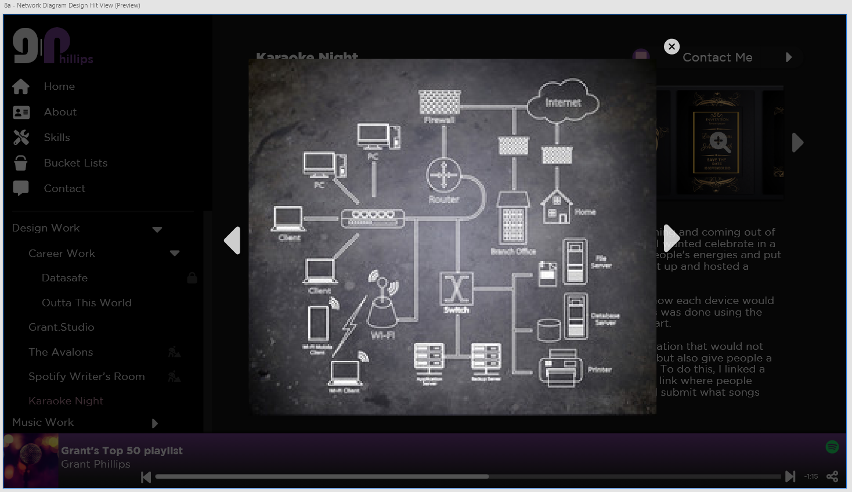

**Notes –**

* **Users can cycle through/preview images associated with this hit.**

**Video Hit**

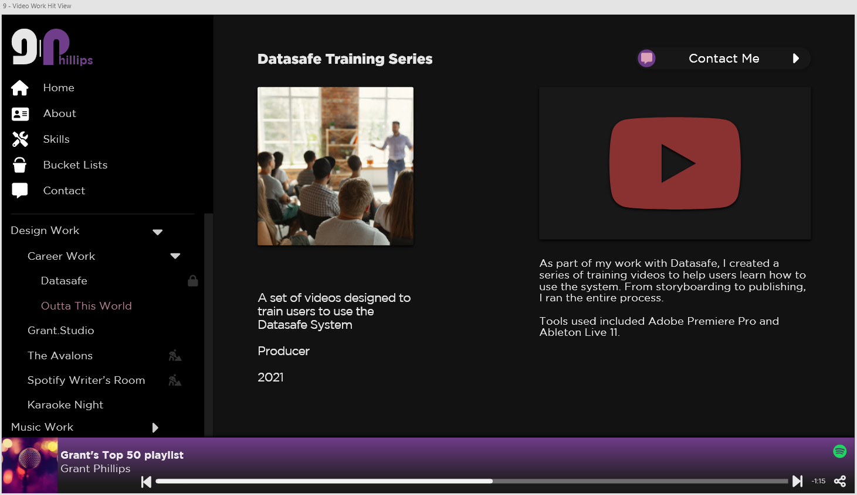

**Notes –**

* **Users can view embedded YouTube videos in this screen.**

**Music Hit**

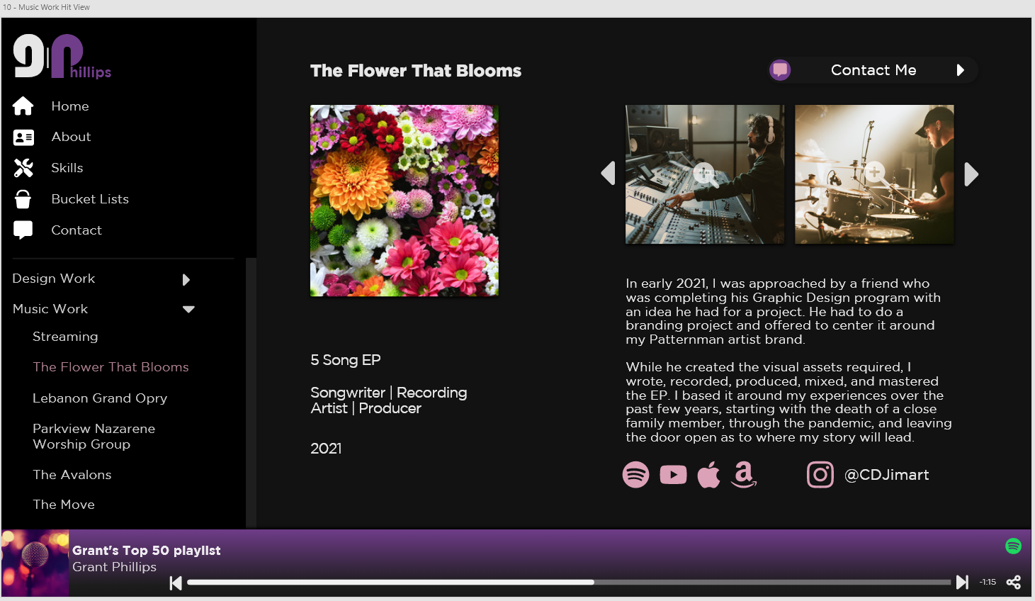

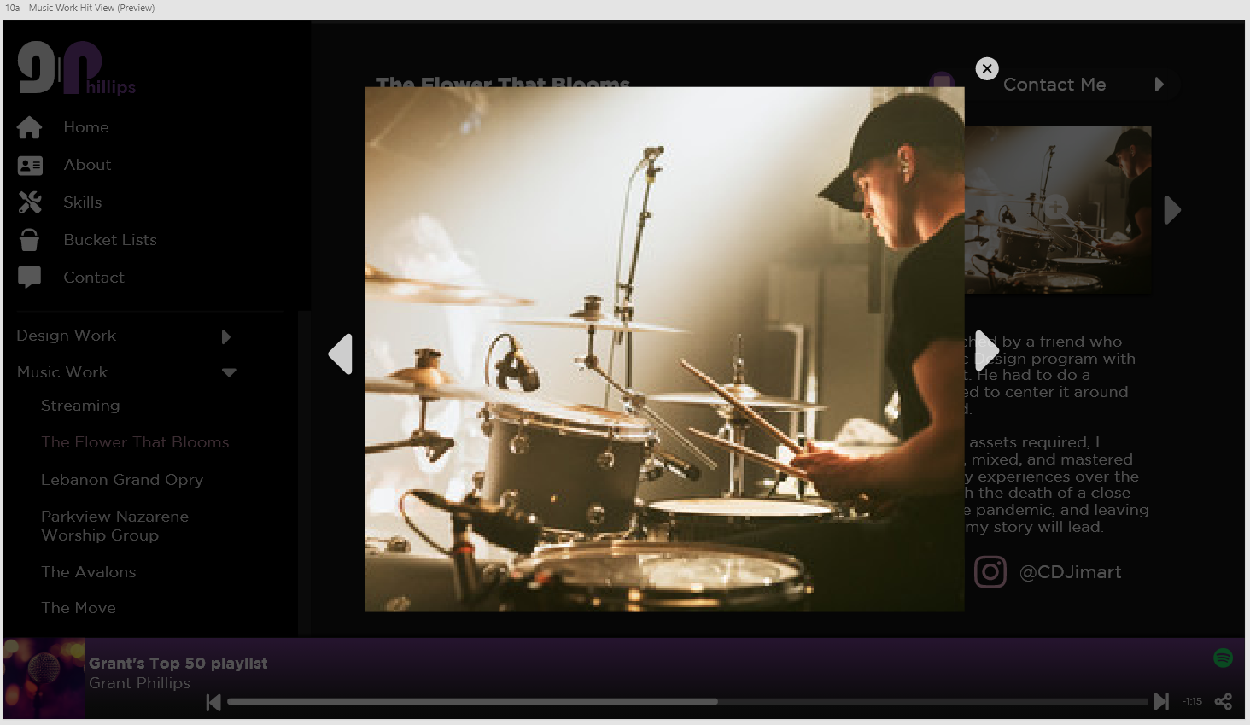

**Notes –**

* **Users can cycle through/preview images associated with this hit.**
* **Users can navigate to external social media links from this page.**

**Under Construction Hit**

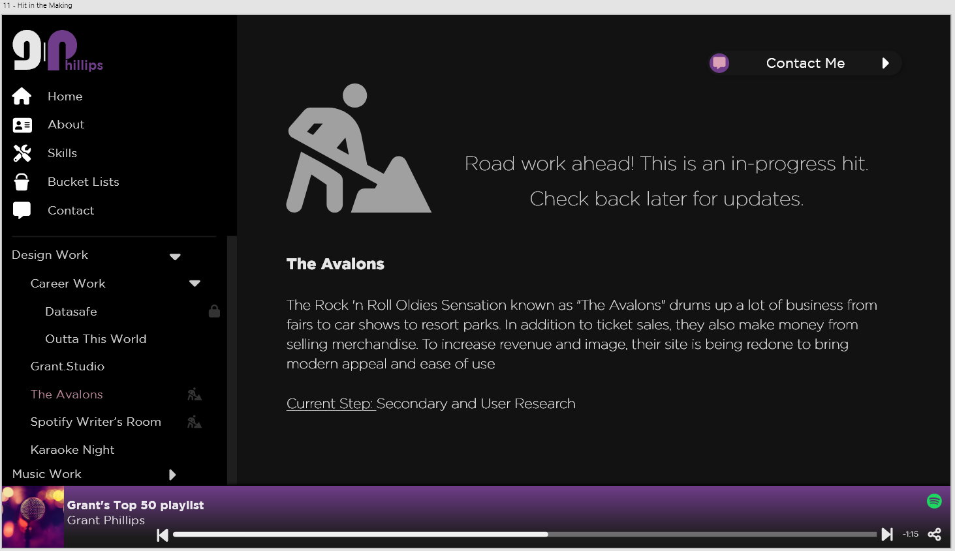

**Notes –**

* **If a hit is flagged as “Under Construction” on the Django Admin screen, this screen is shown instead of the usual Hit screen**
* **This screen displays the Hit name and the description of the Hit**
* **This screen displays what step is currently being worked on.**

**Locked Hit**

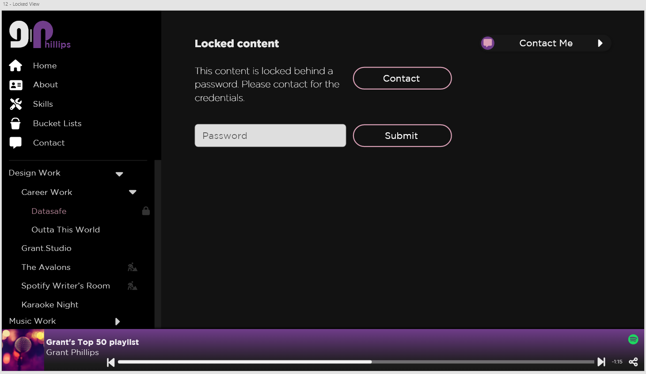

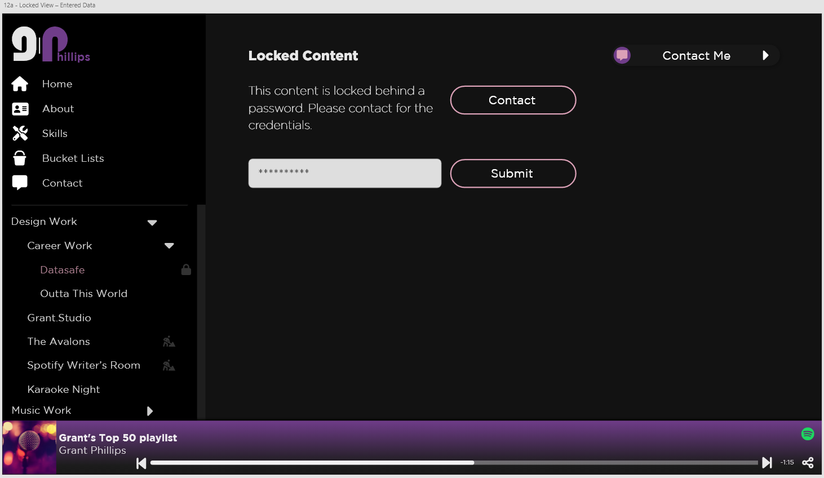

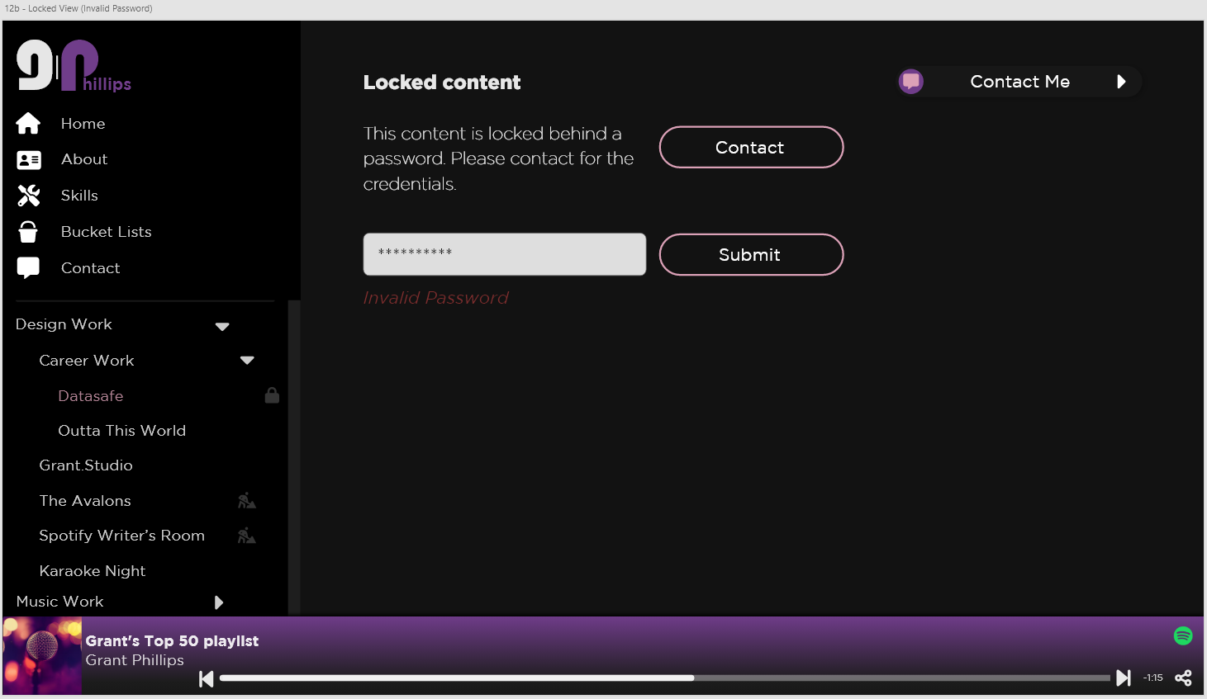

**Notes –**

* **If a hit is marked as “Password Protected” then a correct password must be entered in order to access the hit**
* **Passwords can be used by multiple users.**
* **Passwords are set in the Django Admin screen**
* **If a wrong password is entered, then an error is displayed.**
* **If the correct credentials are entered, then the user is directed to the Hit.**
* **A correct password is required every time a user navigates to a locked hit.**
  + **If a user browses away from the locked hit after successfully gaining access, they still must enter the correct password.**

**Django Admin**

**What to Load from Admin Screen –**

* **Contact Details:**
  + **Phone Number**
  + **Email**
  + **Social Links –** 
    - **Social Name**
    - **Social Image**
    - **Social URL**
* **About:**
  + **About Sections –** 
    - **Section Title**
    - **Section Text**
    - **Section Image**
* **Skills:**
  + **Skill Sections –** 
    - **Section Title**
    - **Section List**
      * **List Entries**
    - **Section Image**
* **Bucket Lists:**
  + **Skill Sections –** 
    - **Section Title**
    - **Section List**
      * **List Entries**
    - **Section Image**
* **Hit Collections:**
  + **Collection Parent**
  + **Collection Title**
  + **Collection Description**
  + **Collection Image**
* **Hits:**
  + **Design Hit:**
    - **Collection Parent**
    - **isLocked Flag**
    - **isUnderConstruction Flag**
    - **isHidden Flag**
    - **Hit Image**
    - **Hit Title**
    - **Hit Description**
    - **Hit Role(s)**
    - **Start Year**
    - **End Year**
    - **Hit Image(s)**
    - **Hit Summary**
    - **Hit Summary Image**
    - **Hit Problem Statement**
    - **Hit Problem Statement Image 1**
    - **Hit Problem Statement Image 2**
    - **Hit Research**
    - **Hit Design Steps –** 
      * **Step Name**
      * **Step Order Number**
      * **Step Tool Tip Text**
    - **Hit Design Images Set 1**
    - **Design Text**
    - **Hit Design Handoff Steps –** 
      * **Step Name**
      * **Step Order Number**
      * **Step Tool Tip Text**
    - **Hit Design Images Set 2**
  + **Diagram Hit:** 
    - **Collection Parent**
    - **isLocked Flag**
    - **isUnderConstruction Flag**
    - **isHidden Flag**
    - **Hit Image**
    - **Hit Title**
    - **Hit Description**
    - **Hit Role(s)**
    - **Start Year**
    - **End Year**
    - **Hit Image(s)**
    - **Hit Summary**
  + **Video Hit:**
    - **Collection Parent**
    - **isLocked Flag**
    - **isUnderConstruction Flag**
    - **isHidden Flag**
    - **Hit Image**
    - **Hit Title**
    - **Hit Description**
    - **Hit Role(s)**
    - **Start Year**
    - **End Year**
    - **Youtube Embed Code**
    - **Hit Summary**
  + **Music Hit:**
    - **Collection Parent**
    - **isLocked Flag**
    - **isUnderConstruction Flag**
    - **isHidden Flag**
    - **Hit Image**
    - **Hit Title**
    - **Hit Description**
    - **Hit Role(s)**
    - **Start Year**
    - **End Year**
    - **Hit Image(s)**
    - **Hit Summary**
    - **Hit Social Links –** 
      * **Social Link Name**
      * **Social Link Image**
      * **Social Link URL**
* **Passwords:**
  + **Group -** 
    - **Group Name**
    - **Group Password**

**Future Work**

**Notes –**

* **Would like to eventually add a Calendar to display my availability/events I’m attending.**
* **Would like to eventually include a blog.**
* **More smooth, eye catching animations are a big plus.**